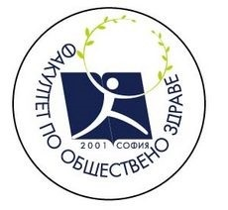
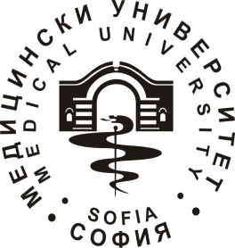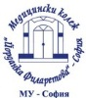

1ST International Sofia Staff Week & 30th Anniversary of Erasmus: New horizon in Public Health and Health Care services

16-20.10.2017

Programme

Day | Activity | Hour | Meeting  Point | Participants
16.10.17  Monday | Registration Desk  Welcome Coffee | 9:30–10:30 | University Hospital St. Ekaterina - aula | All
 | Welcome speech – Rector of MU-Sofia ,Dean of FPH and Director of Medical College | 10:30-11:00 | University Hospital St. Ekaterina - aula | All
 | Ice-breaking Welcome  Presentation of Faculty of Public Health  Presentation of Medical College  Introduction round of participants of the International Week I | 11:00–13:00 | University Hospital St. Ekaterina - aula | All
 | Lunch | 13:00 |  | All
 | Introduction round of participants of the International Week II | 14:00 –16:00 | University Hospital St. Ekaterina - aula | All
 | Sofia Tour | 16:00 | Sofia City Centre | All
17.10.17  Tuesday | Medical College Tour | 11:00-11:45 | Medical College – J. Filaretova | All
 | Workshops:  (all specialities) | 12:00 –13:00 | Medical College – J. Filaretova | Depend on interests
 | Meet me with your country!  - Typical food  - Exchanging contacts | 13:00 –15:00 | Medical College – J. Filaretova  (Gym) | All
 | Tour of the Museum History of Sofia | 15:15 |  | All
18.10.17  Wednesday | Hospital Tour  - City Clinic Tokuda Hospital  - Military Меdical Academy  - Gynecological Hospital  For Medical College  - Cosmetics’Centrums  - Rehabilitation Centrums  - City Clinique  - City Clinic Tokuda Hospital (medical lab technicians)  (upon the interest of paticipants) | 10:00 | •City Clinic Tokuda Hospital  •Military Меdical Academy Hospital  •Gynecological Hospital | Depend on interests
 | Free for lunch | 13:00 |  | All
 | Practical session “Health and Beauty Care” lead by Students, specialty Medical Cosmetics, with active involvement of all participants | 14:00-16:00 | Medical College – J. Filaretova | All
 | Official Dinner with Prof. Tz. Vodenitcharov, Dean of the Faculty of Public Health, Medical University-Sofia, Rector and Director | 19:00 | Traditional Bulgarian Restaurant | All
19.10.17  Thursday | Workshops  Presentations II | 10:00-12:00 |  | Depend on interest
 | Free for Lunch | 12:00 |  | All
 | Cultural program | 13:00
20.10.17  Friday | Official closing ceremony | 11:00 | Military Medical Academy | All
 | Lunch | 13:00 | Catering | All

