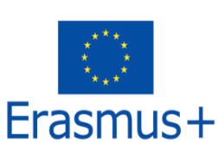****

**MUSTAFA KEMAL UNIVERSITY**

**8TH ERASMUS+ STAFF WEEK**

**02 - 06 October 2017**

**GENERAL INFORMATION AND APPLICATION FORM**

**GENERAL INFORMATION**

**AIM OF THE EVENT**

Our main goal to organize the 8th Erasmus+ Staff Week is to create an opportunity for our current or expected partners to introduce their universities, to learn about Turkey and Turkish culture, and to share experiences with others while carrying out Erasmus Teaching or Training activity in the frame of Erasmus+ Staff Exchange program. A five-day program was planned with this aim.

Any academic or administrative staff working at our partner universities or other European universities willing to make new collaboration can apply for the 8th Erasmus+ Staff Week which will take place in Antakya, Hatay, Turkey in **02-06 October 2017**.

**APPLICATION**

Three staff from each university will be accepted to the event at most, but this limitation may change depending on the number of applications. Because of this, anyone willing to join the event can send an application. The total number of participants will be limited to 20 people.

Those willing to join the event should download the application form from the International Office’s web site (<http://int.mku.edu.tr>, Erasmus menu) and then fill in the Application Form and send it to [mkuerasmus@gmail.com](mailto:mkuerasmus@gmail.com) and [erasmus@mku.edu.tr](mailto:erasmus@mku.edu.tr) by e-mail. It is not necessary to send the application form by regular mail.

The status of the application will be determined within about one week after the application form has been received. A letter of invitation will be sent to the staff whose application is accepted.

**COSTS**

There is no participation fee for the program. Participants should only cover their travel and accommodation costs. Costs for the excursion, transportation, lunches, and dinners mentioned in the program will be covered by the Mustafa Kemal University Erasmus Office.

Participants may contact their university’s Erasmus Office to obtain Erasmus+ program staff mobility grants to cover the costs.

**LANGUAGE**

The language of the event is English. We require sufficient knowledge of English from all participants.

**ABOUT ANTAKYA AND HATAY**

Hatay is one of the 81 provinces of Turkey. It is located in the mid-south of Turkey. Antakya is the central city of the Hatay province. The main campus is located in 15 km north of the Antakya city center and about 10 km south of the Hatay international airport (please see the map below). Antakya is famous for its cultural and historical assets (mainly mosaic artifacts), St.Peter’s grotto church, Turkish and middle eastern cuisine, and beaches.

**TRANSPORTATION**

Hatay has an international airport which is about 25 km north of the Antakya city center and 10 km north of the Mustafa Kemal University Main Campus. The Main campus named “Tayfur Sökmen Campus” is between Antakya city center and the airport (please see the map below). We will arrange a pickup from the airport for all guests.

Flights are available from both Istanbul and Ankara (capital city) to Hatay International Airport. You should buy your flight ticket to Hatay International Airport.

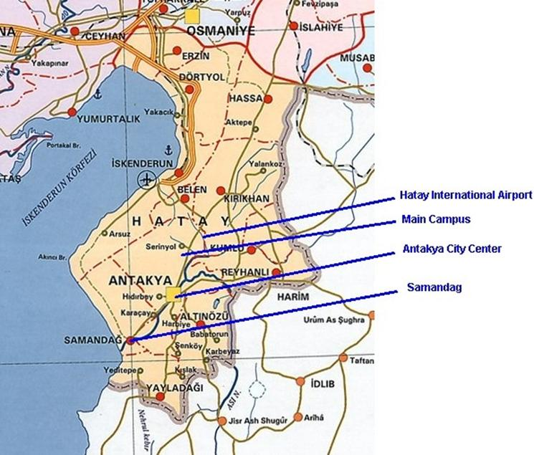

**CLIMATE AND WEATHER CONDITIONS**

It is generally warm in October in Antakya. The average temperature is about 20-25ºC at daytime and 10-15ºC at night. Rain could be expected.

**CURRENCY**

The currency in Turkey is Turkish Lira (TL). Other currencies including Euro and USD can be exchanged in currency exchange offices or in banks located in the city center. Most shops usually accept payments in Euro and USD. As of April 2017, 1 Euro is about 4.00 TL and 1 USD is about 3.70 TL.

**ACCOMMODATION**

MKU Guest House: (will be booked by the MKU Erasmus Office)

Our university has a guest house in Antakya city center located on the main street (Ataturk Street). It has 25 rooms. All rooms have TV and bathroom inside. The guest house also has a small restaurant in the first floor. Breakfast, lunch, and dinner are served in the guest house.

As of April 2017, the price is about 60-65 TL (about 15-20 Euros) for a single room and 65‑70 TL (about 20-25 Euros) for a double room per night (including breakfast and taxes). (1 Euro = 4.00 TL)

Address: Mustafa Kemal Üniversitesi Rektörlük Misafirhanesi, Atatürk Caddesi, 31040 Antakya, Hatay

(Mustafa Kemal University Rectorate, Guest House, Ataturk Street, 31040 Antakya, Hatay)

**CONTACT INFO:**

**Address:** Mustafa Kemal University Rectorate

International Relations & Erasmus Office

Tayfur Sokmen Campus

31040 Antakya, Hatay, Turkey

**Phone:** +90 326 221 5815 (Within Turkey: 0 326 221 5815)

**E-mail:** [mkuerasmus@gmail.com](mailto:mkuerasmus@gmail.com), [erasmus@mku.edu.tr](mailto:erasmus@mku.edu.tr)

**Internet:** MKU Faculties and Departments Course catalog: <http://bbs.mku.edu.tr>

MKU International Office: <http://int.mku.edu.tr>

MKU main web page: <http://www.mku.edu.tr>

<end>