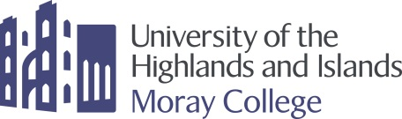

STAFF TRAINING WEEK 22-26 MAY 2017 - PROGRAMME

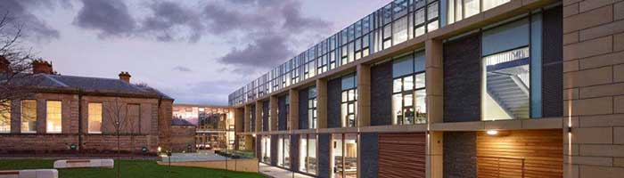

Monday 22 May 2017

10:00 Registration and Principal Welcome
11:00 Coffee and tea with snacks from participant countries
11:30 Programme for the week
12:00 Introduction to UHI and how we got here
13:00 Lunch
14:00 Candidate presentations
15:30 Free-time
19:00 Dinner and whisky tasting - hosted by Moray College

Tuesday 23 May 2017

09:30 Coffee
10:00 Workshop – Academic areas and Support Services working together – discussion and sharing of best practice
13:00 Lunch
14:30 Distillery Tour
17:00 Free Evening

Wednesday 24 May 2017

09:30 Workshop – Different Cultures and Integration into the University and local Community
11:30 Trip to Loch Ness (Packed Lunch provided)
18:00 Free Evening

Thursday 25 May 2017

09:30 Meet individual departments
11:00 Depart Elgin to Findhorn
Tour of Eco Village
Visit to Heritage Centre and Ice House
15:00 Dolphin watching experience in the Moray Firth with North Sea 58
18:00 Dinner and Ceilidh and Findhorn Yacht Club

Friday 26 May 2017

10:00 Coffee and presentation of certificates
11.00 Feedback Round, Perspectives, Wrap-up & Farewell session
12.30 End of Programme

