SVEUCILISTE JOSIPA JURJA STROSSMAYERA U OSIJEKU
JOSIP JURAJ STROSSMAYER UNIVERSITY OF OSIJEK - UNIOS
Sluzba za medjunarodnu suradnju / International Relations Office
Rektorat / Rectorate, HR-31000 Osijek, Trg Sv. Trojstva 3
Phone: +385 31 224 125
Fax: +385 31 224 126
www.unios.hr/incoming-mobility OIB: 78808975734

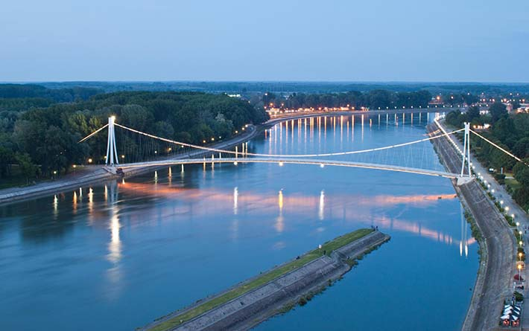

SOME practical information for visiting UNIOS

Dear colleagues,
We are looking forward to welcoming you soon at the University of Osijek.
Here are some information regarding your preparation for arrival and stay in Osijek.

For all additional information, please contact us any time:

E-mails:
erasmus@unios.hr
martina@unios.hr

Phone: 00385 31 224 171 (office hours: 8.00 am – 3.00 pm)

Planning of travel

Flying to Croatia
The main Croatian airport is located in Zagreb and it is well connected to many European destinations. Osijek, however, has a local airport, which offers some international direct flights.

More information about timetables and destinations is available on the official site of Croatia Airlines (www.croatiaairlines.com), as well as on the web page of the Osijek airport web page http://www.osijek-airport.hr or by phone +385 31 284 611.

Railway travel
Croatia has direct railway links with many European countries and cities. Information about Croatian railways and connections to Osijek https://prodaja.hzpp.hr/en

Bus travel
Bus lines connect all parts of the country. Regular international bus lines connect Croatia with all neighboring countries. For information about national and international bus lines please check the site of Central Bus Station in Zagreb (www.akz.hr) and the site of Bus Station in Osijek: https://www.arriva.com.hr/en-us/home
There are also frequent bus connections operated by FlixBus https://www.flixbus.hr/

The easiest way
The easiest way to reach Osijek from abroad is to fly to Zagreb and to transfer to flight to Osijek. Another option is to fly to Zagreb and continue by train or bus to Osijek. There is shuttle bus from the Zagreb Airport to the main bus station in Zagreb and the train station is Zagreb is near the bus station.

The train/bus service from Zagreb is frequent, safe and reliable and takes approximately 3.5 hours to reach Osijek. A one-way ticket from Zagreb to Osijek costs approx. 15,00 EUR.

Flying to Budapest or to Belgrade is another option, however, there are not many connections by bus or by train to Osijek from Budapest or from Belgrade, so it is a bit difficult to organize travel schedule without quite long waiting for connections.

BY CAR
The fastest transport is by car, using Zagreb-Osijek highway (275 km/2:45 hours) which is part of European highway E70, coming from Bregana direction Zagreb-Lipovac-Osijek and then from A3 to A5 highway (European highway E73, known as Slavonika), direction Zagreb-Osijek.

If you are travel by car, we suggest you consult the web page http://maps.mireo.hr/GelinX/ for more details.

Health insurance
The University cannot facilitate any insurance for guests, nor it can take over any damage or costs for guests that may come out due to lacking of insurance!

Therefore, it is highly advisable that you regulate personal health insurance that will be valid during your stay in Croatia.
The health insurance can be provided by an international travel and health insurance policy issued by any insurance company in your home country. Such insurance must be valid for the whole period of your stay in Croatia and you have to have it closed before coming to Croatia.
EHIC – European Health Insurance Card - regulates health insurance for citizens of the European Union countries. It is issued usually free of charge and it is valid over certain time period (usually for one year).

Osijek CITY PUBLIC TRANSPORT

City public transport consists of tram and bus lines.
Single ticket for the first city zone (around city center) is 11,00 HRK (1,50 EUR). The ticket can be bought in tram / bus from the driver and it is valid for one hour.
Single ticket for the second city zone (further city parts and outskirts) is 13,00 HRK.
Daily ticket is 35,00 HRK.
Here you can find all information about the city public transport and all tram and bus lines.

Hotel Accommodation Suggestions

Please, make your own reservation and arrangements directly with the hotel of your choice.

The following accommodation options are recommended, as the facilities are close to the main University building / our Staff Seek venue:

The Osijek Hotel **** Address: Šamačka 4, Osijek
Located in the city center, in the heart of Osijek's pedestrian zone right next to a quiet river port and the Osijek promenade. Distance to the main University building venue is app. 10 minutes on foot. When making reservation, please, mention the reference of the University of Osijek to book rooms at reduced prices.
www.hotelosijek.hr

Single room per night (B&B) = 560,00 HRK*
Double room per night (B&B) = 655,00 HRK*
*discount rates for University guests

The Maksimilian Guesthouse*** Address: Franjevačka 12, Osijek
Guesthouse Maksimilian is situated in the very center of the old town - baroque part of Osijek („Tvrđa“- The Fortress), right next to the main University building venue. Maksimilian is a relaxed, romantic place to stay and all our guests are always pleased with its service. More info at:
http://www.maksimilian.hr/?lang=en

The Merlon Rooms*** Address: Franje Markovića 3, Osijek
The Rooms are located also in „Tvrđa“, right across the main University building (meeting venue). The rooms are well equipped, still they are located on the top floor of the beerhouse, so during weekends it is sometimes noisy. More info at:
https://merlon.hr/
https://www.booking.com/hotel/hr/sobe-merlon-osijek.hr.html
The Central Hotel *** Address: Trg Ante Starčevića 6, Osijek
Located right at the main city square, next to the Church of Sts. Peter and Paul. It is the oldest hotel in Osijek. Walking distance to the main University building is app. 15 minutes, or 5 minutes by tram (direction Zeleno Polje). More info at: http://www.hotel-central-os.hr/eng/index.html

The Waldinger Hotel**** or Waldinger Pansion *** Address: Županijska 8, Osijek
Hotel Waldinger holds four stars and its Pansion right in the hotel back yard is assigned with three stars. It is located in Županijska street, in the centre of the city. The prices of accommodtion depend on the type of room booked either int he hotel ori n the pansion. Walking distance to the main University building is also app. 15 minutes. More info at: www.waldinger.hr

The Lisnic Rooms *** Address: Strossmayerova 15, Osijek
Located in the city center, some 100 meter away from the main square. Walking distance to the main University building is app. 20 minutes, or 5 minutes by tram (direction Zeleno Polje). More info at:
http://www.sobe-lisnic.com/en/

The Vienna Apartments **** Address: Stjepana Radića 26, Osijek
Located in the city center, some 200 meter away from the main square, situated opposite to the Faculty of Law and the Faculty of Economics. Walking distance to the main University building is app. 20 minutes. More info at: http://www.vienna-smjestaj.com/index.php/en/

The Red Blue Apartments *** Address: Ružina 23, Osijek
Located in the city center, Ružina 23, Osijek, some 200 meter away from the main square. Walking distance to the main University building is app. 20 minutes. The apartment is brand new, just opened for guests. Apartments are fully equipped. More info at: https://www.facebook.com/apartmaniredblue/

The University of Osijek – main building

Address Trg Svetog Trojstva 3, Osijek

Meeting time: Monday, 10 June 2019, at 10.30 a.m.

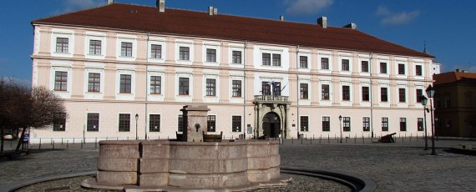

Interactive map of Osijek for easier orientation:
http://www.karte.hr/osijek

Hope to see you soon!

