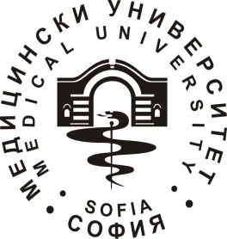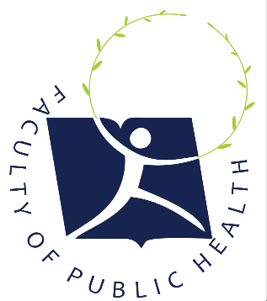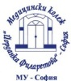

2nd International Sofia Staff Week: Innovations in Public Health Education

01-05. October 2018
Day | Activity | Hour | Meeting point | Groups of interest
01.10.2018 | Registration desk | 09:30 - 10:00 | St. Ekaterina Hospital | All
 | Welcome speech | 10:30 - 11:00 | St. Ekaterina Hospital | All
 | Participant’s presentations I | 11:00 - 13:00 | St. Ekaterina Hospital | All
 | Lunch | 13:00 - 14:00 | St. Ekaterina Hospital | All
 | Participant’s presentations II | 14:00 – 16:00 | St. Ekaterina Hospital | All
 | Official dinner | 19:30 | Restaurant Vodenitsata | All
02.10.2018 | Network meeting | 10:00 – 12:00 | Medical College | All
 | Medical College Tour | 12:00 - 13:00 | Medical College | All
 | Meet me with your country!  Typical national food | 13:30 – 15:00 | Medical College | All
 | Sofia tour | 15:30 – 17:00 | Down town | All
03.10.2018 | Hospital tour | 10:00 – 12:00 |  | Depends on interest
 | Flexible lunch | 12:30 – 14:00
 | Practical Beauty and Rehabilitation Session | 14:30 – 16:30 | Medical College | All participants
 | Erasmus Cocktail Party | 20:00 | Sense Roof Top Bar | Depends on interest; flexible
04.10.2018 | Workshop I | 10:00 – 12:00 | Medical College | Depends on interest
 | Flexible lunch | 12:30 – 14:00 | Pizza place
 | Workshop II | 14:30 – 16:00 | Medical College | Depends on interest
05.10.2018 | Tsari Mali Grad – Ancient Fortress | 09:30 – 15:30 | Belchin, Bulgaria | All participants
 | Tsari Mali Grad Tour
 | Farewell Lunch
 | Belchin’s Church

