UNIVERSITY OF THESSALY
INTERNATIONAL RELATIONS OFFICE
1st International Staff Training Week
28th March 2016- 1st April 2016

About the University
The University of Thessaly is situated in Thessaly, Greece. The university is based in Volos, along with its administration offices, but there also are campuses in other major cities in Thessaly, Larissa, Trikala, Karditsa and Lamia.
You can find information about the city’s sights on the sites below:
- http://www.dimosvolos.gr
- http://www.larissa-dimos.gr
- http://www.trikalacity.gr
- http://www.karditsa-city.gr/
- http://www.lamia.gr
Volos is a coastal city in Thessaly situated midway on the Greek mainland, about 326 kilometres north of Athens and 215 kilometres south of Thessaloniki. It is the capital of the Magnesia regional unit. It is built at the innermost point of the Pagasetic Gulf and at the foot of Mount Pilio (Pelion, the land of the Centaurs).
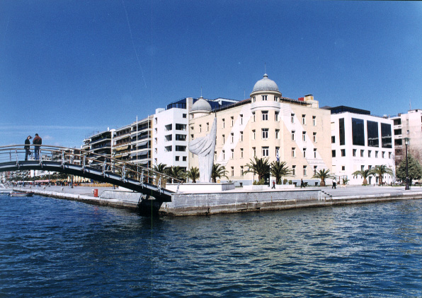
The University of Thessaly was founded in 1984. The university comprises of five schools—Humanities and Social Sciences, Engineering, Agricultural Sciences, Health Sciences and Sciences. It is divided into 18 departments offering undergraduate and post-graduate degrees programmes.
- School of Engineering (Volos)
  - Department of Mechanical Engineering
  - Department of Planning and Regional Development
  - Department of Civil Engineering
  - Department of Architecture
  - Department of Electrical and Computer Engineering
- School of Humanities (Volos)
  - Department of Primary Education
  - Department of Early Childhood Education
  - Department of Special Education
  - Department of History, Archaeology and Social Anthropology
  - Department of Physical Education and Sport Science (Trikala)
  - Department of Economics
- School of Agricultural Sciences (Volos)
  - Department of Agriculture Crop Production and Rural Environment
  - Department of Ichthyology and Aquatic Environment
- School of Health Sciences
  - School of Medicine (Larissa)
  - Faculty of Veterinary Science (Karditsa)
  - Department of Biochemistry and Biotechnology (Larissa)
- School of Sciences (Lamia)
  - Department of Computer Science and Biomedical Informatics
  - Department of Computer Sciences

University History

The University of Thessaly was founded in 1984. Its administrative and academic centre is in the city of Volos. In its initial phase of organization and operation there have been eight Departments. Since 1984 and onwards the University of Thessaly has been gradually growing with new Departments in the four biggest cities of the region of Thessaly. Recently, a new Department has been founded in the city of Lamia.
The main mission of the University of Thessaly is the promotion of scientific knowledge through research and the contribution to the cultural and economic development of the local community and wider society. The members of the academic and research staff participate in European research networks and numerous innovative research projects in the EC.
Emphasis is also given on the bond between the University of Thessaly and the local society. This bond is further supported by the operation of the University Hospital of Larissa which covers the medical needs of the whole region of Thessaly. The University brings also students in contact with the labour market through its Career Office, and it encourages a great deal of social activities and public lectures on various issues held by qualified academic staff. Student life in the University of Thessaly is also rather intense. The students have established well-organised associations which are highly active in the fields of sports and culture.
It is a University with its own identity and with a prominent position in our national educational system, known for its quality in teaching, research, human resources, spirit of cooperation at all levels and a dynamic presence in the society.

