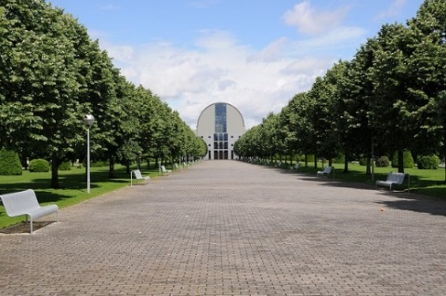

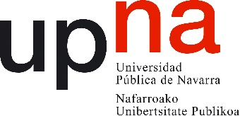

PUBLIC UNIVERSITY OF NAVARRE - SPAIN
(E PAMPLON02)

INTERNATIONAL STAFF WEEK May 15th- 19th
"Internationalization and Cooperation for Development in Higher Education Institutions: Erasmus + Projects"

Personal Data

Name |  | Surname
Function
Name of the Home Institution |  | Erasmus Code

Contact Details

Mobile Phone |  | Office Phone
Email

Participation

Does your current job involve working in Erasmus + Projects? Any K2 project? If so, please indicate their names/codes
Would you like to present the Erasmus + projects run at your institution? If so, please add a brief summary to this application form
Special interests

Logistics

Special requests
Date of arrival and departure:
Would you like us to provide you a list of hotels?

Please send the application form to:
convenios.internacional@unavarra.es
BRIEF SUMMARY OF YOUR PRESENTATION
If possible, related to K2 projects
(no more than 20 lines)

