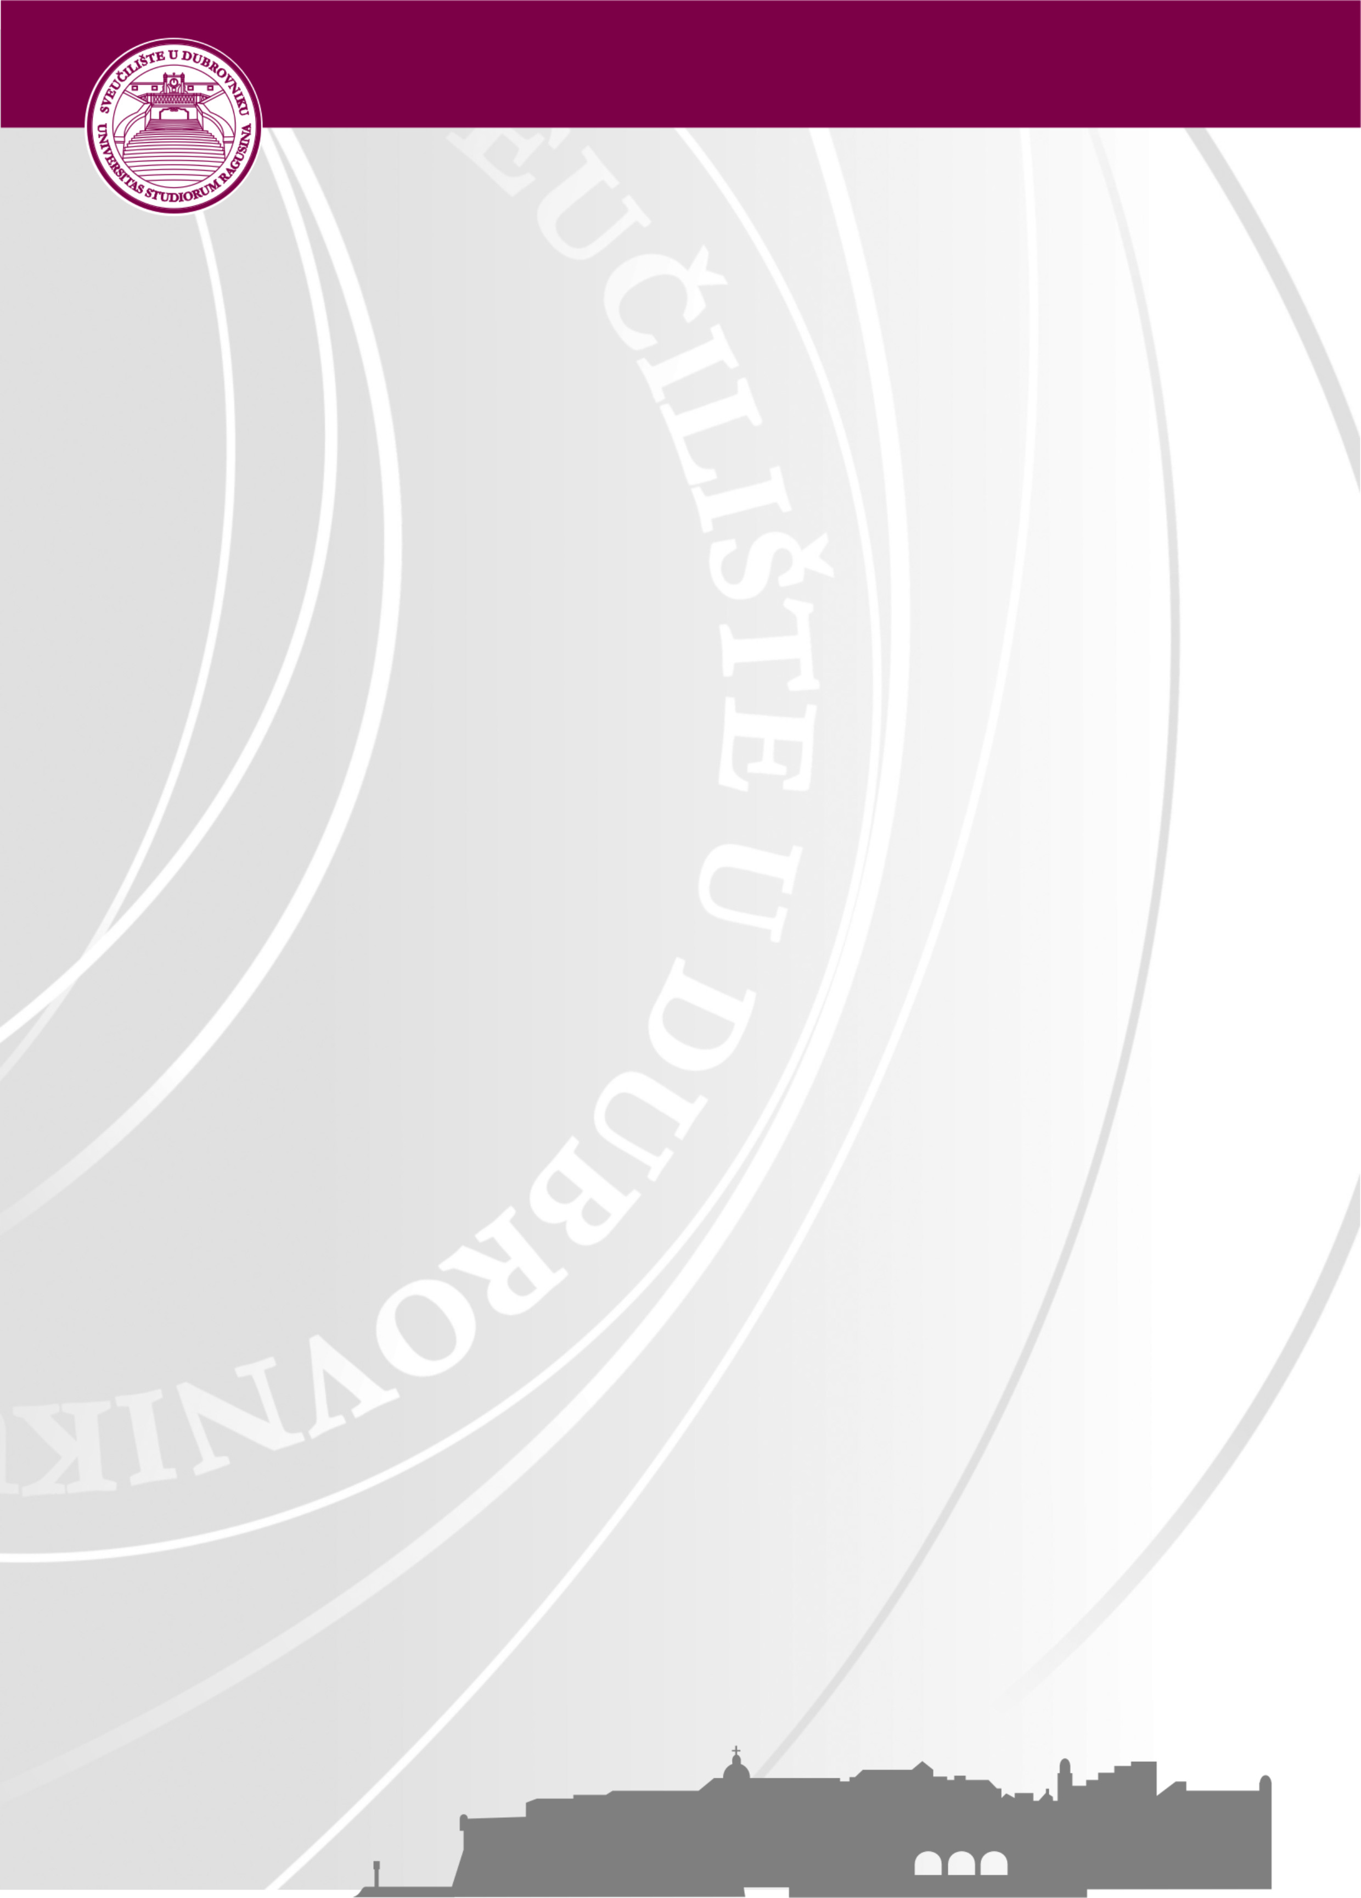
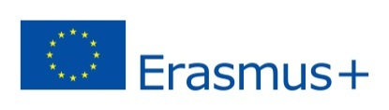
University of Dubrovnik
Erasmus+ Week
9-13 April, 2018
Application Form for Teaching Mobility

Name/Surname:
Title/Position:
Institution/ City/ Country:
Department at home institution:
E-Mail:
Scientific Field (eg. Mathematics,Economic,Engineering….)
Suggested topics for teaching
Comments/special requirements (any special IT equipment should be stated here)

Please send the filled Application form with your ERASMUS+ MOBILITY AGREEMENT and CV till February 28th, 2018 to international@unidu.hr.

We will inform you about the approval of your application by March 9th, 2018. at latest. After the acceptance confirmations are sent, more details about the final Program will be provided to participants. The Program will include lecturing at UNIDU departments, participation at the Erasmus+ International fair, as well as different social activities. Please note that transport and accommodation is a personal responsibility of the selected candidates.
In case of any further questions, please do not hesitate to contact Mrs. Sandra Memunic at: international@unidu.hr or sandra.memunic@unidu.hr , Tel. +385 20 446 041.
We look forward to welcoming you at the University of Dubrovnik!

