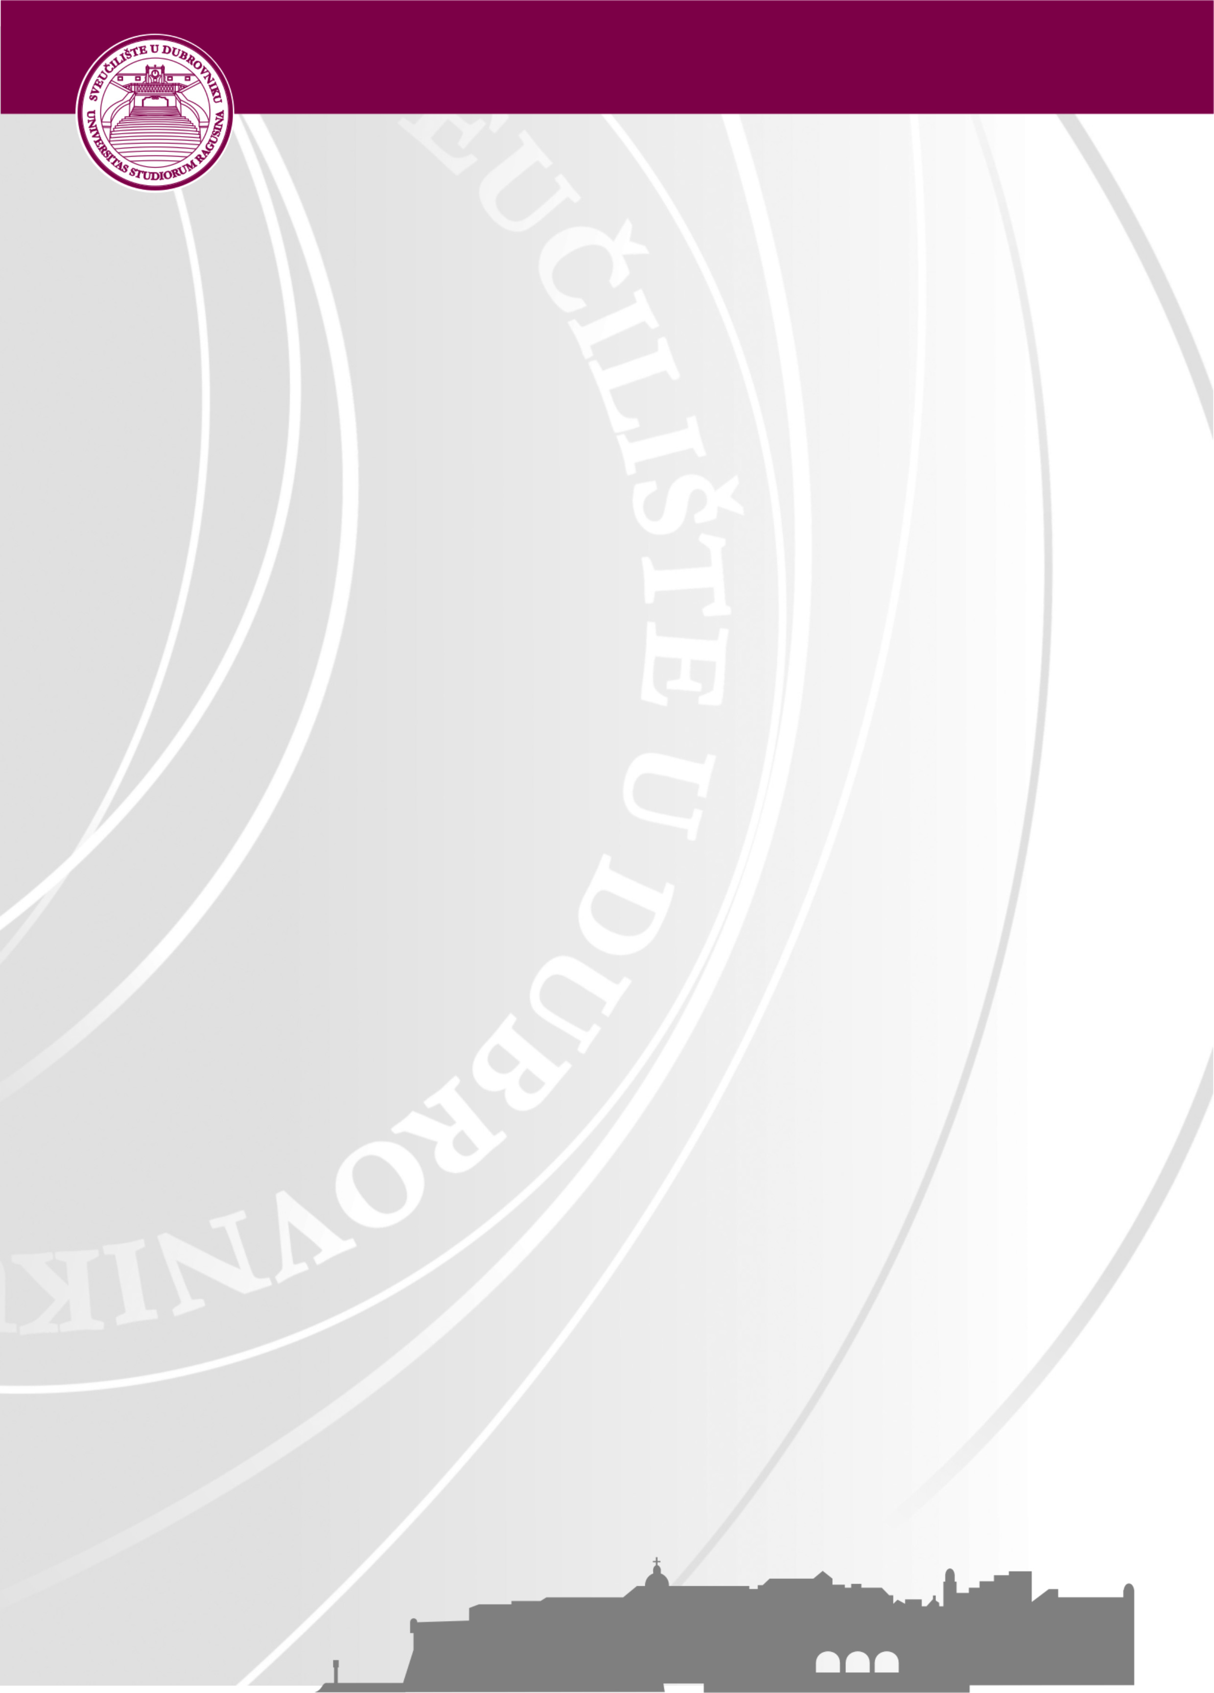
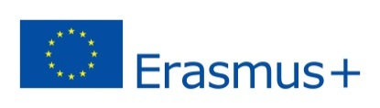
University of Dubrovnik
Erasmus+ Week
9 - 13 April, 2018
Application Form for training mobility
(for non-teaching staff only)

Name/Surname:
Title/Position:
Institution/ City/ Country:
Department/Office at home institution:
E-Mail:
Main responsibilities:
Comments/special requirements:

Please send the filled Application form with your ERASMUS+ MOBILITY AGREEMENT till February 28th, 2018 to international@unidu.hr.

The working language will be English and we will organise “job-shadowing” activities for participants. Beside this, it is expected that selected participants will present their home institution at the Erasmus+ International Fair held during this week.
Please note that the places are limited and there is a possibility that we will not be able to organise job shadowing for all applicants. We will inform you about the approval of your application by March 9th, 2018. at latest. After the acceptance confirmations are sent, more details about the final Program will be provided to all participants. The Program will include job-shadowing activities, participation at the Erasmus+ International Fair as well as social activities for all participants. Please note that transport and accommodation is a personal responsibility of the selected candidates.
In case of any further questions, please do not hesitate to contact Mrs. Sandra Memunic at: international@unidu.hr or sandra.memunic@unidu.hr , Tel. +385 20 446 041.
We look forward to welcoming you at the University of Dubrovnik!

