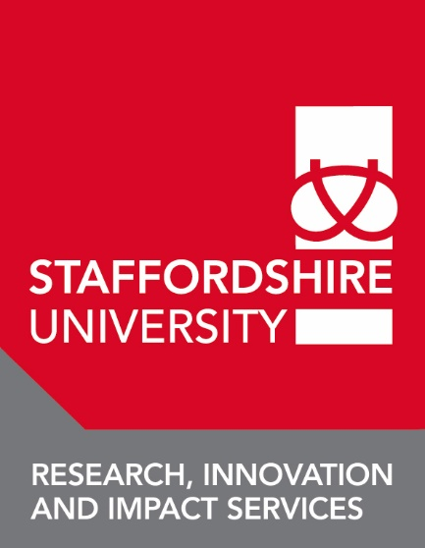

Staffordshire University Erasmus+ Training Programme, International Week
19th – 22nd March 2018
Application Form

Name:

Institution:
Social media channels:
E-mail:
Confirm e-mail:
Current position within your organisation:

What are your areas of expertise?
Music Film Drama/Performing Arts/Theatre Studies

