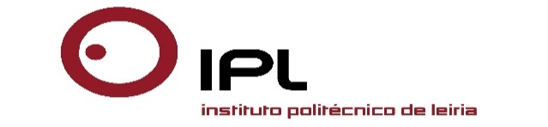

OPEN WEEK 02-06 NOVEMBER 2015

‘Collaborative Higher Education Institutions- New Internationalization Paths ’

POLYTECHNIC INSTITUTE OF LEIRIA

Application form

Please, return this form before October 15th 2015 to
acecilia@ipleiria.pt

☐ Ms ☐ Mr

Name: First Name:
Institution:
Function:
Address:

Postal Code / City / Country:
Tel.: Fax:
E-mail:

Department of your interest in IPLeiria:

Special requirements:
______________________________________________________________

______________________________________________________________

Accommodation (During the staff week):

Teachers Residence Hall ☐
Casulo das Memórias – Private Residence Hall ☐
Hotel Eurosol ☐

Social Programme

Bus Trip – Touristic Locations in the District ☐

Welcome Lunch ☐

Farewell Dinner ☐

If you have some doubts on the existing programme, contact:
acecilia@ipleiria.pt

