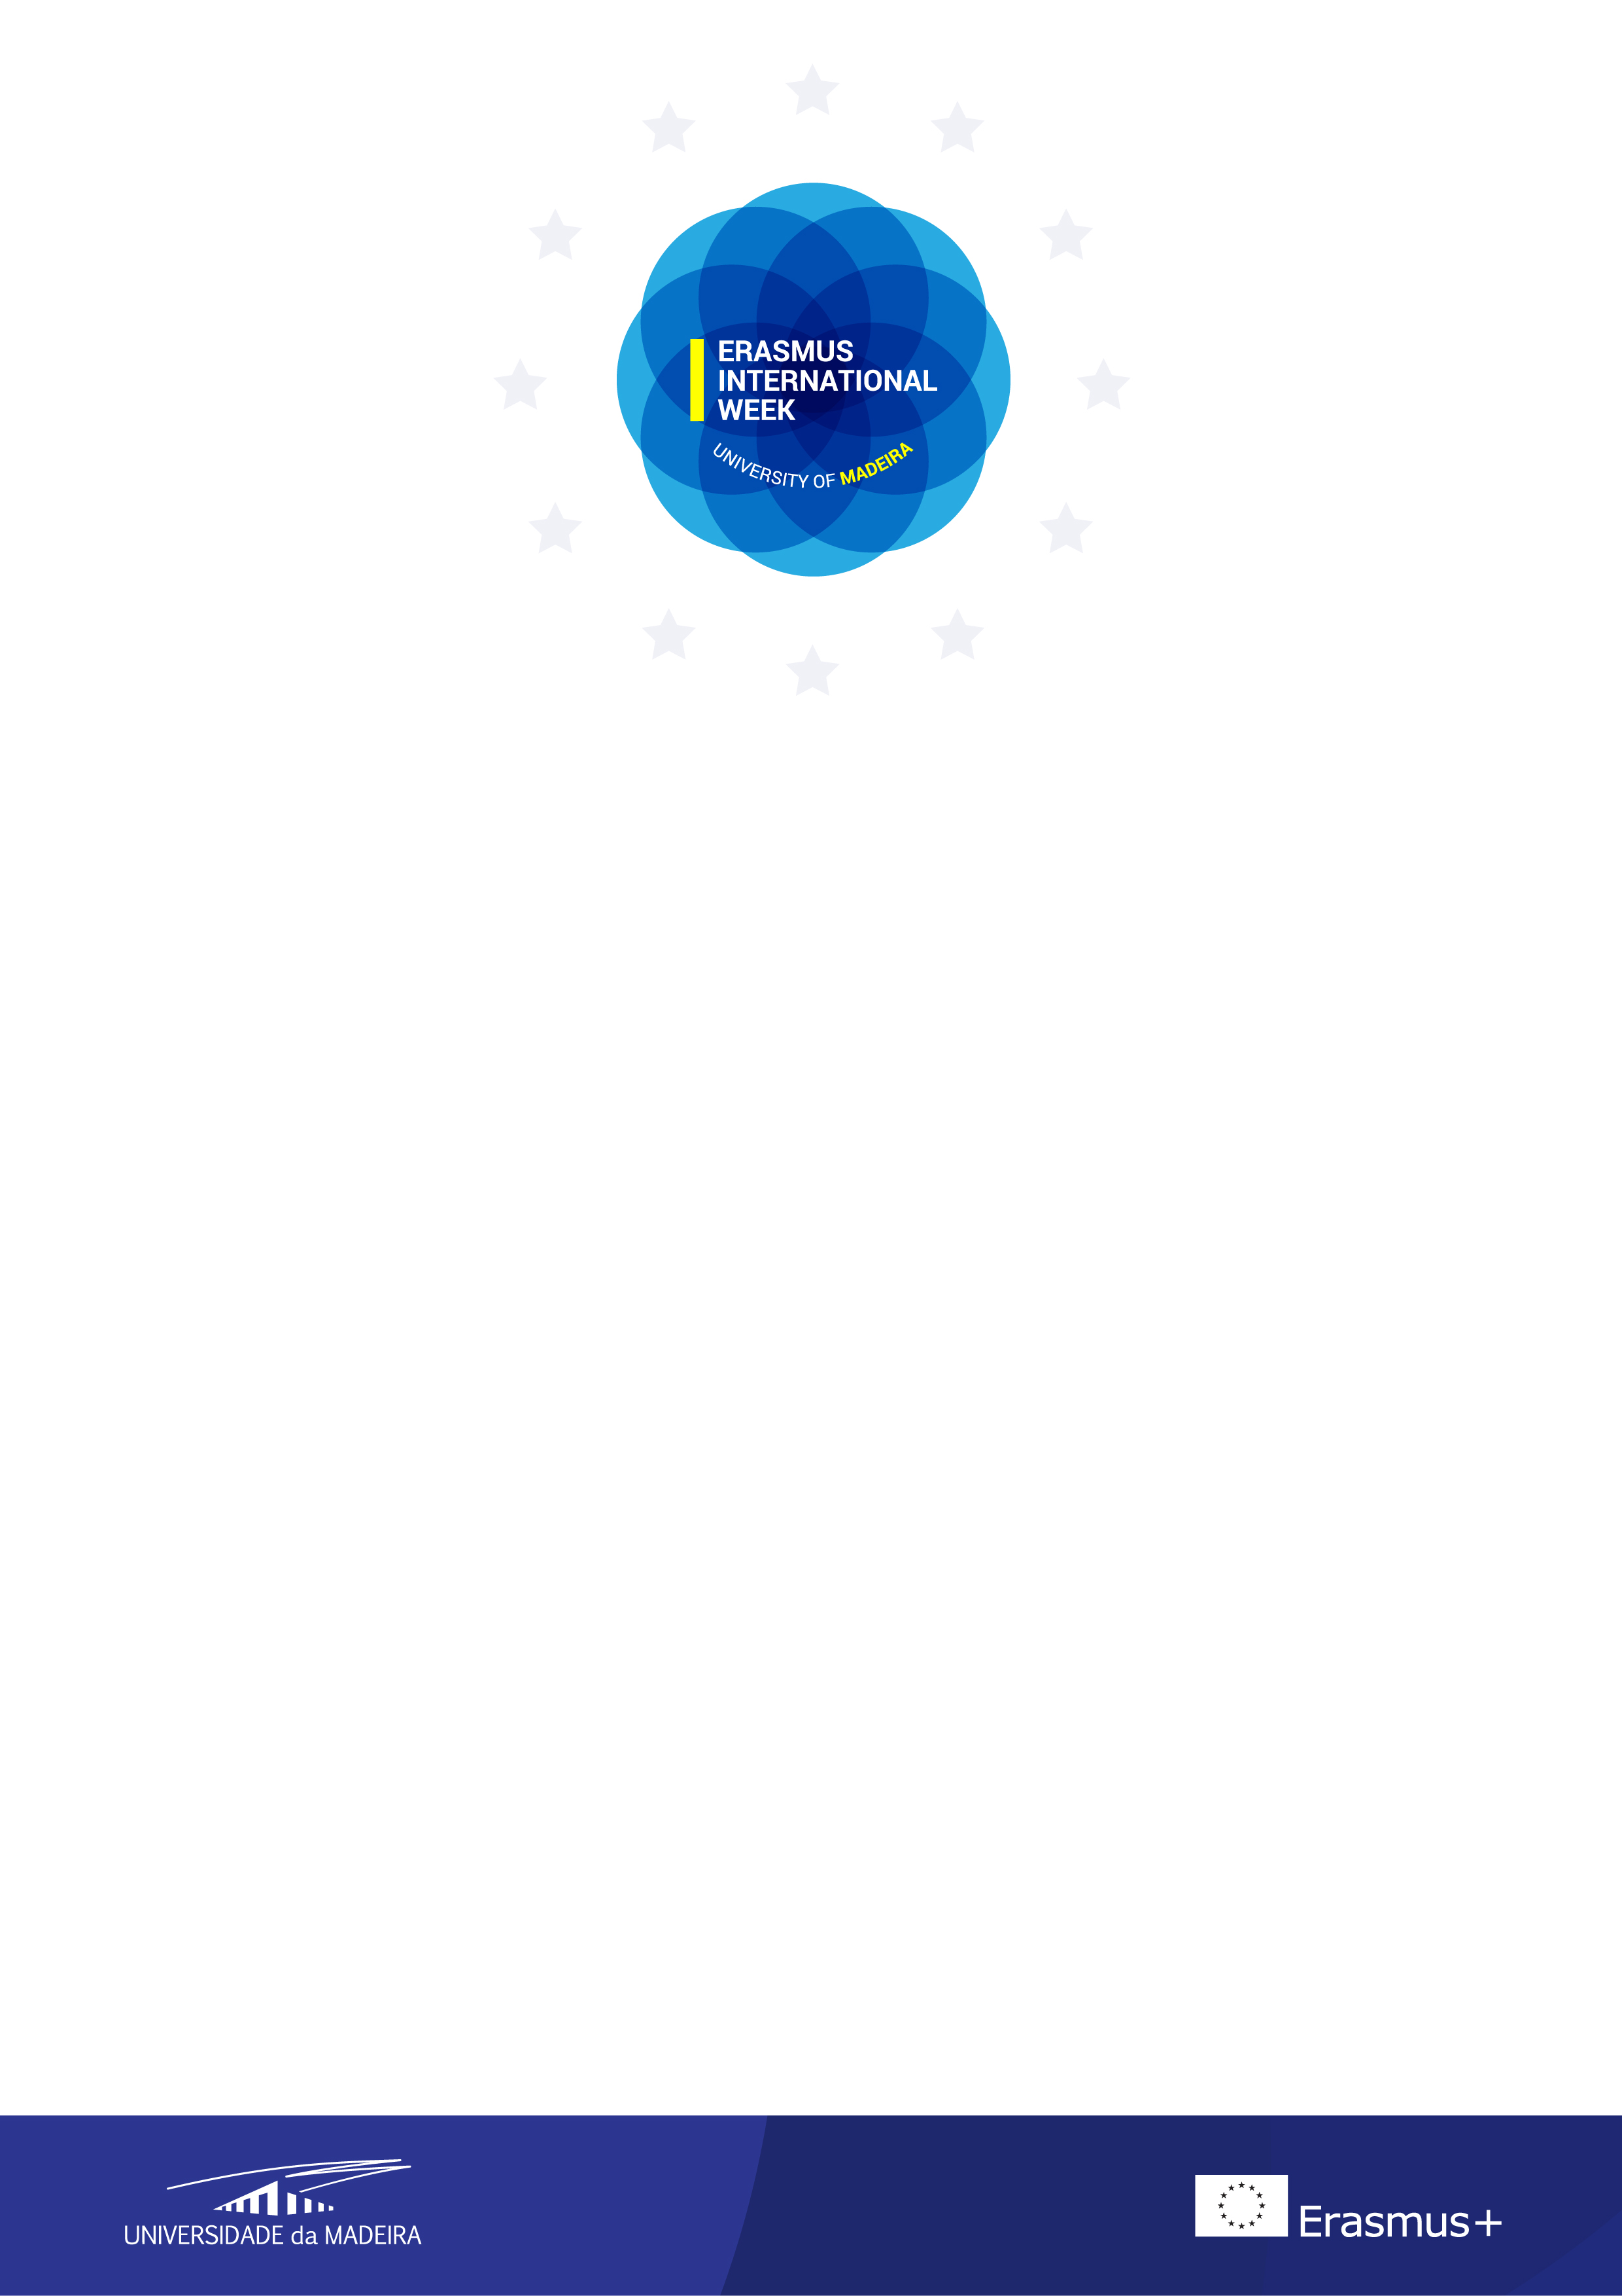

APPLICATION FORM
Universidade da Madeira (P FUNCHAL03)
18^{th -} 20th April 2016
- PERSONAL DETAILS
First name
Family name
E-mail
Home institution
Erasmus code
Department
Position
The programme is mainly designed for University staff working in International Relations or issues related to internationalization. The University of Madeira will share its own experience, and would like to encourage an active exchange information, about good practices.

- INDIVIDUAL MEETINGS:
Please inform us if you would like to visit a particular Department/Service/Faculty/School and to have an individual meeting:

- OTHERS
Special requirements (please state if you have any food allergies or dietary requests):

Note: The language of the I ERASMUS International Week will be English. We can accept up to 20 participants.

Please return this application form by e-mail to paula.barreto@staff.uma.pt or upc@uma.pt

