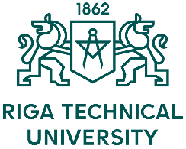 | Application Form  7th INTERNATIONAL STAFF TRAINING WEEK  May 28 – June 1, 2018  Riga Technical University
Title:
Surname:
Name:
City and country:
University:
Department:
Position:
Main responsibilities:

Contact data:

Address:

E-mail:

Mobile telephone number:

I would like to join (Only one option possible!):
□ International group
□ Financial group

Please state the reasons for participation at the International Week:

Optional social program including:  - Lunch (Monday, 28 May)  - Welcome dinner (Monday, 28 May)  - Riga city tour (Tuesday, 29 May)  - Tour to Jūrmala including lunch (Thursday, 31 May)  60 EUR fee will be collected during registration. | YES | NO
Please send your completed application form by 15 March 2018 to jolanta.jurevica@rtu.lv

