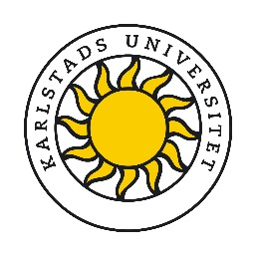
International Staff Exchange Week 10th – 14th June 2019
Application Form
In this application form Karlstad University will request information about your proposed staff exchange, as well as request information connected to this. The purpose of the form is to gather information in order for the International Office to ascertain if the guidelines for staff exchange are fulfilled and to register applications in relevant record systems.
In order to fulfill the purpose outlined above personal data about staff, such as name, contact details, home institution, upcoming exchange period, contact person etc., will be collected and processed.
Participation is voluntary and you can withdraw your consent at any time without stating a reason. It will, however, not change the processing of personal data that has already taken place before the withdrawal of consent. Karlstad University will ensure there is no unauthorized access to the data.
The data could be transferred to third country if necessary.
By signing this document, I consent to Karlstad University processing my personal data in accordance with the current Data Protection Regulation and the information submitted.
For further information about the processing of personal data, please see links below:
In Swedish: https://www.kau.se/GDPR
In English: https://www.kau.se/en/GDPR
- Personal Details
Name:

University:

Position and Department:

Please provide a brief description of your role:
- Contact Details
Telephone:
Email:
- Job Shadowing
In which area of the University are you interested in job shadowing:

Signed: |  | Date:

Please email completed form to collaboration@kau.se no later than 6th March 2019
Prior to the week we would like distribute a list of participants, their position and University to all participants, if you do not wish your details to be included please let us know.

