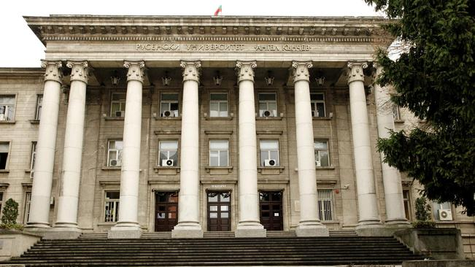

APPLICATION FORM

THIRD INTERNATIONAL STAFF WEEK „NEW AGENDA OF THE EUROPEAN HIGHER EDUCATION INSTITUTIONS“

University of Ruse, BULGARIA
June 13 – 17, 2016

Personal information:
Title:
Surname:
Name:
City and country:
Department:
Position:
E-mail:
Mobile phone:

Please tick off your form of participation: (you may choose more than one option)
Presentation of your university and its participation in international programs (14.06.2016)

Participation in the workshop “The New Agenda of the European Higher Education Institutions” with a presentation on the following topic: (15.06.2016)
- Good Practices of internationalization of Higher Education
- Educational needs of digital students generation
- Challenges to the Erasmus + Programme
Picnic at Ivanovo Rock Churches (15.06.2016)
Dinner (16.06.2016): price: 25 euro (paid upon arrival)

Excursion to Veliko Turnovo (17.06.2016): price: 35 euro (paid upon arrival)
Note: the excursion will be organized at participation of minimum 10 participants.The price includes transportation and lunch.

Please send your completed application form before 24 April 2016 to e-mail stafftraining2016@uni-ruse.bg
All approved applicants will be contacted personally by the end of April.

