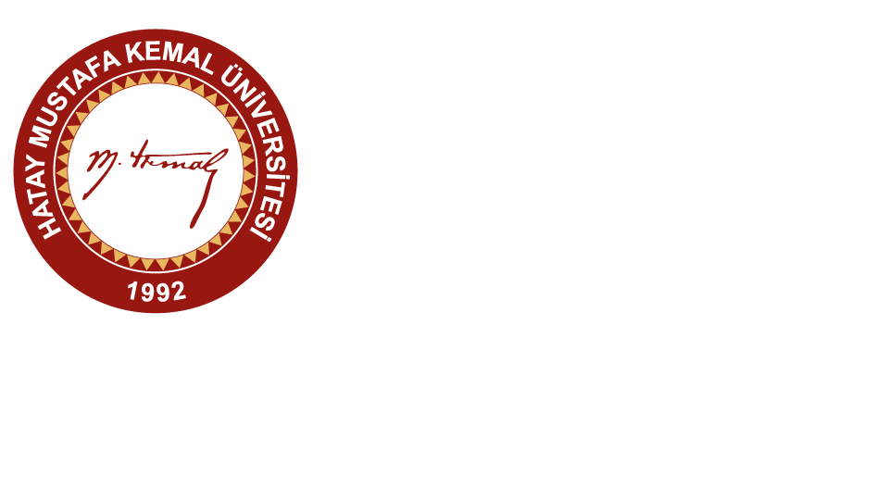
HATAY MUSTAFA KEMAL UNIVERSITY
12th ERASMUS+ STAFF WEEK
27 – 30 APRIL 2020
APPLICATION FORM
STAFF MOBILITY FOR TEACHING OR TRAINING ASSIGNMENT
First Name
Last Name
Job Title
Seniority | Junior Intermediate Senior
Gender | Female Male
Country
Passport Number
Name of the Home University
Erasmus ID Code
PIC Number
Faculty / School
Department / Unit / Office
Address
E-Mail
Mobile Phone
Activity Type | Teaching Training
Activity Topics
Department to be Visited
Arrival Flight Number
Arrival Date and Time
Departure Date and Time
Food Restriction (if any)
(Such as vegeterian, etc.)
Special Needs (if any)
Accommodation | will arrange self. Hotel name: ………………………………….  MKU Guest House (will be booked by the MKU Erasmus Office)  Travel expenses will be paid by the participants.
Do you want to give a seminar to other participants and audience in the morning sessions?
What are your expectations about participating in this event?
Remarks (if any) | No

