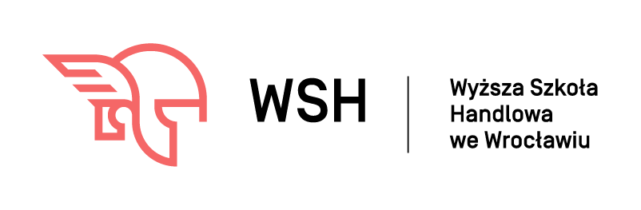

APPLICATION FORM

INTERNATIONAL STAFF WEEK
20-24 April, 2020

WYŻSZA SZKOŁA HANDLOWA WE WROCŁAWIU
(UNIVERSITY OF BUSINESS IN WROCLAW)

PL WROCLAW12

53-238 Wrocław, Ul. Ostrowskiego 22 · e-mail: barbara.kobzarska-bar@handlowa.eu

PERSONAL DATA
FIRST NAME, FAMILY NAME:

DEPARTMENT/FACULTY:

POSITION:

E-MAIL ADDRESS:

PHONE NUMBER:

HOME UNIVERSITY
OFFICIAL NAME:

OFFICIAL NAME IN ENGLISH:

ADDRESS:

ERASMUS CODE:

NAME & E-MAIL ADDRESS OF ERASMUS COORDINATOR:

DATE OF ARRIVAL AND DEPARTURE
ARRIVAL: | DEPARTURE:

TOPIC(S) OF THE LECTURES (STA)

TOpics Of PRESENTATIONS OR TRAINING (stt)
TOPIC of the lecture:

TOPIC of presentations/training:

AREA (disciplines of science)/DEPARTMENT:

LEVEL OF ENGLISH:

lower silesia trip
Programm:
- Church of Peace in Swidnica, the largest wooden baroque church in the world
- Książ, the largest castle in the Silesia region
- Underground City Osówka, the last and the most developed Hitler’s headquarters, built in Lower Silesia
Price: 70€ (all transports, tickets, lunch)
I want to take part in Lower Silesia Trip:
yes
no

Date: …………………………………………………….. Signature of Applicant: …………………………………………………….

Please return your application form by e-mail to
barbara.kobzarska-bar@handlowa.eu
until 15 March 2020

