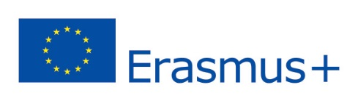
APPLICATION FORM – STAFF
3rd INTERNATIONAL WEEK – INTERNATIONALIZATION
30th November – 4th December 2015
First Name:
Surname: Gender: M/F
Institution (Name, Address):
City, Country:
Position and Title:
Brief job description:

Brief indication of interest:

Working language and its level:
E-mail: Cell phone:
Arrival Date, Time:
Departure Date, Time:
Letter of Acceptance: YES/NO

Teaching staff:
Lecture title 1
Lecture title 2
Department
Duration – each lecture is at least 2 hours:
Language of the lecture – English (min. B2 level), another language:
Short introduction of the lecture:

Other special requirements for the lecture (computers and projectors are provided):

Non-teaching staff:
Presentation/workshop (tick, please):
- About the institution
- On internationalization
Approx. duration:
Short description of your workshop/presentation. Which audience will be addressed?

Special requirements for the workshop/presentation:

CULTURE/FREE-TIME EVENTS organized for you: (circle/tick your interest, please):
- 30th November - Orientation walk in České Budějovice
- 30th November in the evening – Welcome Dinner with the Rector
- 1st December – Tour to UNESCO City of Český Krumlov
- 2nd December – Tour to Vodňany (Faculty of Fisheries and Protection of Waters)
- 2nd December in the evening – Advent Market
- 3rd December – Tour to Hluboká Castle
- 4th December – Guided Tour in Budwar Brewery
Accompanying persons: YES/NO. If yes, number of persons:

Dietary requirements (vegetarian, gluten-free diet etc.):

Hotel rooms are booked by the organizer, ask please for the booking with all information concerning your arrival and departure as soon as possible on: (fichtnerova@jcu.cz).

We are looking forward to seeing you in our university!

