6th International Teacher and Staff Week
Draft Program

Monday April 16th, 2018 | Tuesday April 17th, 2018 | Wednesday April 18th, 2018 | Thursday April 19th, 2018 | Friday April 20th, 2018
10.00-10.15-Registration  AUBG Campus, Room 6306, ABF  10.15-10.30-Welcome address by the President’s Office  AUBG Campus, Room 6306, ABF  10.30-11.00 -Warm-up workshop  AUBG Campus, Room 6306, ABF  11.00-11.30- Presentation about Erasmus+ program at AUBG  AUBG Campus, Room 6306, ABF  11.30-13.00-European Gastronomy Fair of traditional food and drinks presented by the participants  AUBG Campus, Room 6306, ABF  13.00-15.00-Guided Tour of AUBG Skaptopara Campus and Main Building  15.00-17.00  Guided tour of Blagoevgrad  19.30-21.00- Cultural program-  10th International festival ”Meeting of Student Choirs” AUBG Campus, Carl Djerassi Theater | 10.00-10.30- Presentation about AUBG - AUBG Campus, Room 6306, ABF  10.30-12.30- Erasmus Fair during which each participant will have the chance to present his/her home University to the others and provide some information materials. The event is expected to serve as a basis for further bilateral agreements between the participating institutions  AUBG Campus, Room 6306, ABF  12.30-13.30- Lunch ( at your own expenses )  13.30-15.30- Bulgarian culture and language workshop  AUBG Campus, Room 6306, ABF  15.30-16.00 Green Initiative  18.30-20.30- Interactive workshop- traditional Bulgarian cuisine  AUBG Campus, Room 6306, ABF  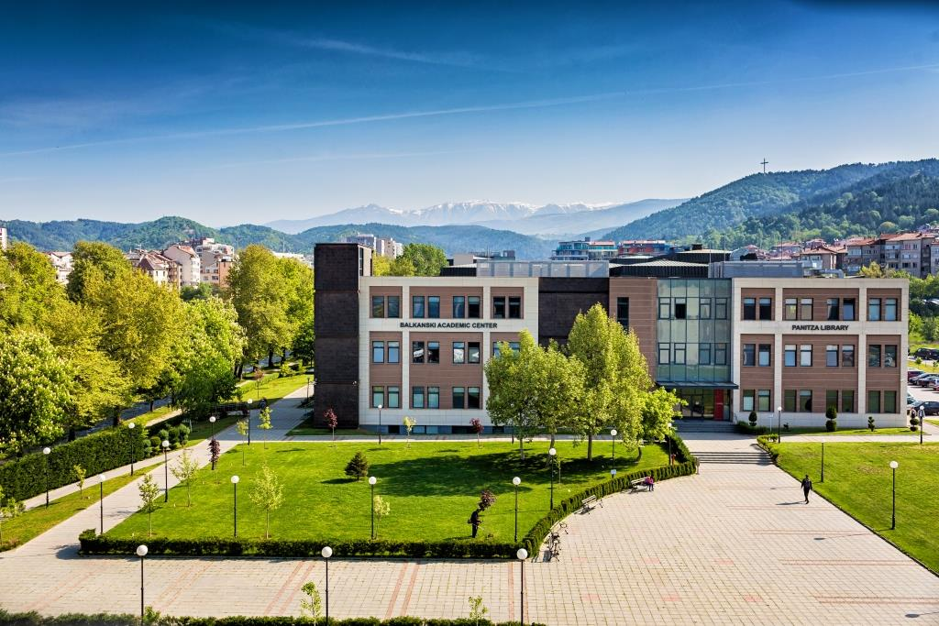 | 9.00 – 17.00  Interactive workshop – Bulgarian traditions and culture presented in Gorno Draglishte - where participants can feel the unique atmosphere of the countryside, cook and try traditional Bulgarian food, learn more about Bulgarian traditions, folk dances and songs.  On their way back the participants will visit the church “ St. St. Theodor Tiron and Theodor Stratilat “ in Dobarsko(built in 1614) Its authentic architecture and unique frescoes and icons make it one of the most memorable pieces of Bulgarian medieval art. The church is included in the UNESCO list of world heritage sights.  Price approximately 20 Euros per person.  19.30 – 21.30- Exchange evening – Students will share their impressions from a foreign country they have visited while they were on exchange  AUBG Campus, BAC, Library – first floor; | 10.00-12.00  World café: Erasmus+ best practices and new opportunities for universities  AUBG Campus, Room 6306, ABF  12.00-13.00- Lunch ( at your own expenses )  13.00-14.00- Interactive workshop – make a traditional Bulgarian “Martenitsa” by yourself  AUBG Campus, Room 6306, ABF  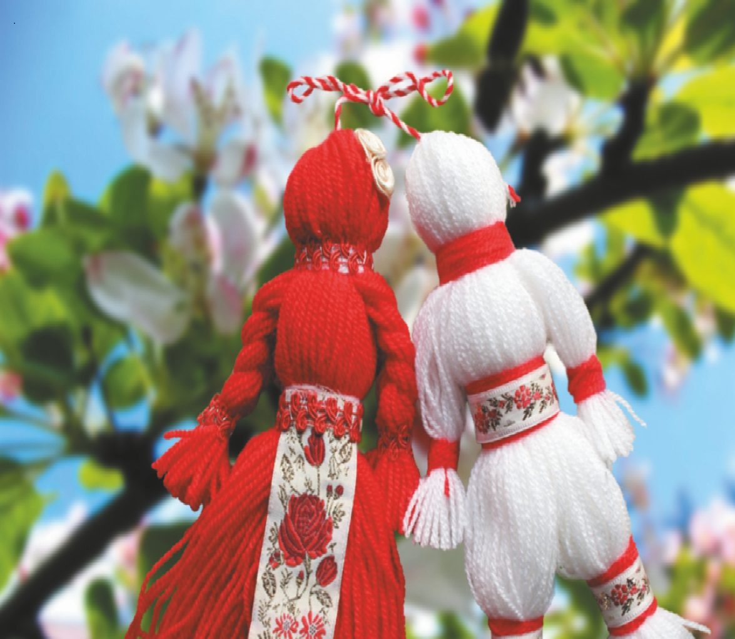  14.15-15.30- Attending an optional lecture by AUBG faculty member  AUBG Campus  15.30-16.30- Presentation about summer schools and programs at AUBG  AUBG Campus, Room 6306, ABF  19.30-21.00- Cultural program-  10th International festival ”Meeting of Student Choirs” AUBG Campus, Carl Djerassi Theater | 9.30-10.30  Closing the 6th Erasmus staff training week, Certificate awards  AUBG Campus, Room 6306, ABF  10.30-15.30  Trip to Rila Monastery (optional) -  price approximately 20 Euros per participant  The Rila Monastery was founded in the 10th century by Saint Ivan of Rila, a hermit canonized by the Orthodox Church. This is the biggest Bulgarian monastery and is one of the 9 UNESCO World Heritage Sites in Bulgaria, designated in 1983. Participants will have the unique opportunity to see the Monastery complex , the main church “The Nativity of the Virgin" , the ancient stone tower(from 13th century), the icon gallery, the extraordinary National historical museum, the Ethnographic museum, some of the premises of the first monastery farm – the kitchen, the fire place, the dairy, the mill etc.  You will enjoy the amazing monastery and the magnificent nature.

