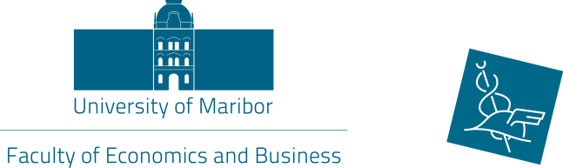

3rd international sCIENTIFIC CONFERENCE
»Teaching Methods for Economics and Business SCIENCEs«

Conference Announcement and Call for Abstracts

14 May, 2019

Faculty Economics and Business, University of Maribor, Maribor, Slovenia

Teaching is a challenging yet rewarding profession which is underpinned by one essential question: how do we build a good teaching and learning environment so that our students can acquire professional competences which will enable them to be successful in today’s global business environment. This question covers a number of (inter)related issues, such as:

- Which teaching methods and techniques can we employ to best fit the subjects we teach?
- Are traditional teaching methods still relevant within university educational process?
- How do we cater for different needs and learning styles of our students?
- Which teaching methods can we apply to develop our students’ ability to generate ideas and evidence?
- How can we encourage students to become active and independent learners?
- What do we know about our students’ motivations and what impact does this have on our teaching?
- How do we integrate modern technology into our teaching?
- How do we inspire creativity in our students?
- How do we facilitate personal development of our students?
- How (often) do we reflect upon our own teaching practice?

We invite scholars and practitioners who teach economics and business subjects to participate at the 3rd International Scientific Conference »Teaching Methods for Economics and Business Sciences« which will take place on 14 May, 2019 at the Faculty of Economics and Business, the University of Maribor, and to report on their teaching methods, to share their experience and examples of good practice as well as to explore future developments in the field.

We welcome proposals for papers on a broad scope of topics related to the theme of the conference:
- different methods and approaches used in teaching economics and business subjects;
- aligning teaching and learning methods with course objectives and learning outcomes;
- teaching and learning with modern ICT;
- using social networks for teaching and learning;
- intercultural dimension in teaching economics and business subjects;
- teaching the millennials;
- stimulating creative thinking of students;
- team teaching and action research;
- other related topics.

Abstract submission
We invite 150-word abstracts in English for the delivery of 15-minute presentations at the conference. To get closer to the deadline for teaching exchange application, the period for abstracts submission is until 20 March, 2019. Please, use the attached form and send it to feb.conference@um.si. The file name should be the first author’s surname. All abstracts will be reviewed by the conference committee and the authors will be notified of acceptance by 31 March, 2019.

Papers
The papers of 3,000–4,000 words should be e-mailed to feb.conference@um.si by 6 May, 2019 at the latest (the papers should be written in English and should be proofread).

The paper template will be sent to you upon the acceptance of the abstract. Please note that the papers will not be accepted unless the speaker(s) has(have) registered for the conference. The registration is free of charge.

All accepted abstracts will be published in a Book of Abstracts and all accepted papers will be published in Conference Proceedings via the University of Maribor Press (http://press.um.si/index.php/ump).

Key dates:
December 2018 | Call for abstracts opens
20 March 2019 | Deadline for abstracts submission
31 March 2019 | Notification abstract acceptance
15 April 2019  6 May, 2019 | Registration for the conference  Deadline for full papers submission

For more information please contact:
Romana Korez Vide, PhD
Faculty of Economics and Business
Razlagova 14, 2000 Maribor, Slovenia
Tel.: +386 2 22 90 122
Fax: +386 2 22 90 217

E-mail: feb.conference@um.si

