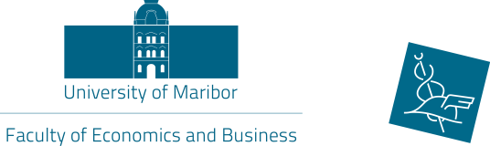
Application form

International week

organized by
the Faculty of Economics and Business

13 –17 May, 2019

1. Personal data:
Full Name
(first name/family name)
Department
Area
Position
Contact details (e-mail address and phone number)
Spoken language(s)
2. Home University:
Official Name
(in English)
Address

ERASMUS Code
Name & contact details of Erasmus Coordinator

3. Topic(s) of the lectures (TSM) or presentations or training (ST):
(Please state min. three topics which you would like to lecture during the International week):

Level of English:
4. Date of arrival and departure:
Arrival:

Departure:

5. International Conference ‘Teaching Methods for Economics and Business Studies’
Would you also like to participate at the Conference?  If yes, please send us also the registration form for the Conference! | YES NO

6. Accommodation recommendations:
Please, make the hotel reservation (email) by yourself!

Hotel Bajt
Link: http://www.hotel-bajt.com/en/

Hotel Maribor – city center
Link: http://hotelmaribor.si/sl/vstopna-stran/

Hotel City – city center
Link: http://www.hotelcitymb.si/en/
Hotel Tabor
Link: http://www.hoteltabor-maribor.si/en/

Mercure Maribor City Center
Link: https://www.terme-maribor.si/en/hotels/mercure-maribor-city-center

Ibis Styles Maribor City Center
Link: https://www.terme-maribor.si/en/hotels/ibis-styles-maribor-city-center

Hotel Habakuk
Link: https://www.terme-maribor.si/en/hotels/hotel-habakuk

Date:
Signature of Applicant

Date:
Signature and stamp of Erasmus Coordinator of Home University
Please return your application form by e-mail to
sanja.kocijan@um.si or polonca.mlakar@um.si or
by fax to +386 2 22 90 217
until Monday, 15 April 2019!

