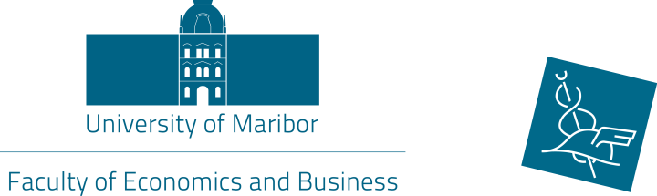

13th International week

Preliminary Programme
13 – 17 May, 2019

13th May, 2019 (Monday)
Faculty of Economics and Business
Lectures (TSM), presentations (ST) and workshops by participants
(Location and schedule will be sent later)
14th May, 2019 (Tuesday)
Faculty of Economics and Business
3rd International Scientific Conference »Teaching Methods for Economics and Business Sciences«
8.30 – 9.00 Registration
9.00 – 9.30 Conference opening addresses
10.00 – 17.30 Paper presentations (*with lunch break)
19.00 *International week dinner

15th May, 2019 (Wednesday)
Faculty of Economics and Business
Lectures (TSM), presentations (ST) and workshops by participants
(Location and schedule will be sent later)
Social programme:
16.00 *City guided tour
17.30 *Vinag wine cellar tour and wine tasting

*Lunch, dinner and social programme are organized by FEB they are free of charge of International week participants.

16th May, 2019 (Thursday)
Faculty of Economics and Business
Lectures (TSM), presentations (ST) and workshops by participants
(Location and schedule will be sent later)

17th May, 2019 (Friday)
Faculty of Economics and Business
Lectures (TSM), presentations (ST) and workshops by participants
(Location and schedule will be sent later)

