TEACH
ENGLISH

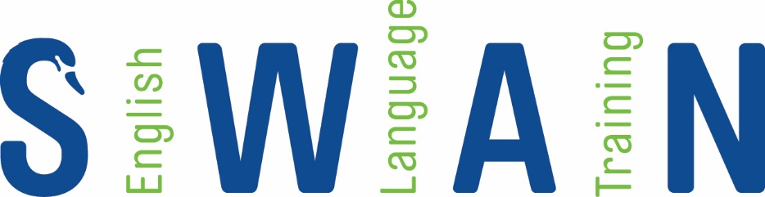

ERASMUS +
TEACHER
TRAINING

ICT in ELT

Swan Teacher Training courses benefit from a dedicated course coordinator, international standards and recognition, modern and relevant syllabi, as well as a friendly and knowledgeable team of trainers. We offer a range of teacher training courses to suit you.

Our Erasmus + specialist courses tap into current European teaching trends to make sure you can offer your students
the best.

We offer flexible dates to suit you and your group, blended learning options, high quality accommodation and an optional social/activities programme.

Dublin is a lively, small and friendly city, the perfect place to take your Erasmus + course!
COURSE LOCATION
Swan Training Institute,
Dublin, Ireland

IS THIS THE RIGHT COURSE FOR ME?
Yes - this course if perfect for teachers who want an
introduction to techniques, ideas and apps which can
support language teaching in your classroom. You can come with some ICT knowledge, or none! We start simply and then share ideas so everyone will go home with plenty of new lesson plans.

TARGET AUDIENCE
- Primary level teachers
- Secondary Level teachers
- Teachers from a range of non-linguistic mainstream subject backgrounds who want to up skill themselves to engage their students via the target language of English
- Language teachers who want to engage their students in a wide range of mainstream subjects and topic areas
- Teachers of students from language and cultural backgrounds different than the native student population

COURSE OBJECTIVES
- To look at the development of ICT in ELT
- To explore uses of ICT in the classroom
- To engage course participants in developing practical ICT teaching tools

COURSE SUMMARY
The methodology integrates presentation of new concepts with elements encouraging participants to reflect and participate as they construct their own ideas of how to integrate ELT into their teaching practice. The course builds on a broad overview of the past quarter century of ICT and its use, and provides CPs with a wide range of practical classroom activities and approaches.
The course uses portfolio based assessment, which provides the participants with a useful body of work to refer to afterwards
Swan Training Institute offer online aftercare, providing an interactive platform for teachers to further develop methodologies
Topics include: ICT in ELT – a history, emerging trends in ICT, publishers and ICT, methods and approaches with ICT

COURSE PREPARATION
Course participants may find the following textbooks useful:
- ICT in ELT (2012, ELT Journal, vol 66/4) by G. Dudeney & N. Hockly
- The Internet and ELT (1999, Summertown Publishing) by D. Eastment
- http://www.teachertrainingvideos.com/
- Technology Enhanced Language Learning (2013, Oxford) by A. Walker & G. White
- The Internet and the Language Classroom (2007, Cambridge) by G. Dudeney
- Digital Literacies (2013, Routledge) by N. Hockly, G. Dudeney & M. Pegrum

*Course participants must have a minimum of B2 English language proficiency

