tional Relations Office
Information about accommodation in Krakow for CUE guests

Useful links for hotel and apartment booking in Krakow

1) Good offers can be found at www.booking.com
2) If you want to check available apartments and their prices, you can visit www.sunandsnow.pl
3) You can find and rent apartments at www.apartments-krakow.pl
4) You can also use www.airbnb.com

Useful links for city transport (trams, buses, airport, tickets, etc.)

1) You can find timetables of city buses and trams departures/arrivals at http://rozklady.mpk.krakow.pl/index.php
2) If you need a piece of information about ticket prices and where to purchase bus/tram tickets, please visit this website: http://www.mpk.krakow.pl/en/
3) We strongly recommend to use http://krakow.jakdojade.pl/?locale=en if you want to check how to get to the certain place (by bus or by tram) and estimate the time needed to reach your destination
4) The official website of the airport Kraków-Balice: http://www.krakowairport.pl/en/

Hotels recommended by CUE

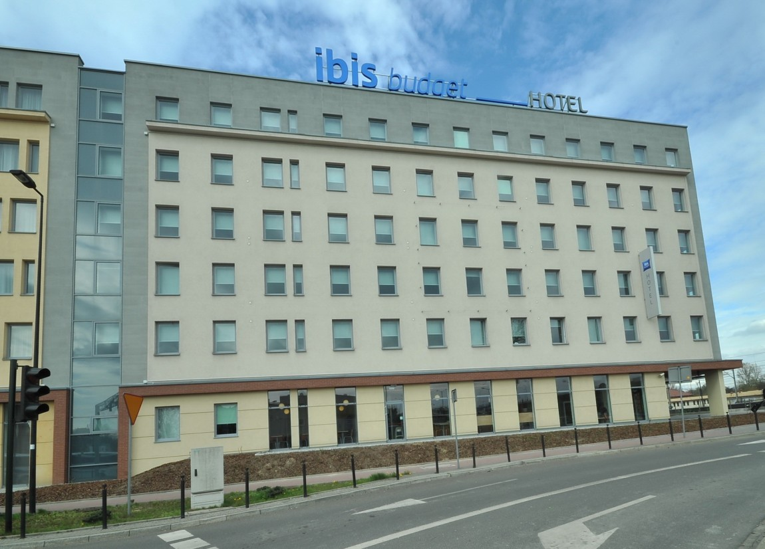
1) Hotel Ibis Budget *
Pawia Street 11
The hotel is located in the heart of Krakow. There is 1 kilometer distance from the Old Town Square. It is also close to the railway station and bus stations with an easy access to the airport.
Distance from CUE: approximately 15-20 minutes walk
For further information about the hotel, please contact: www.accorhotels.com/pl/hotel-7165-ibis-budget-krakow-stare-miasto/in-dex.shtml

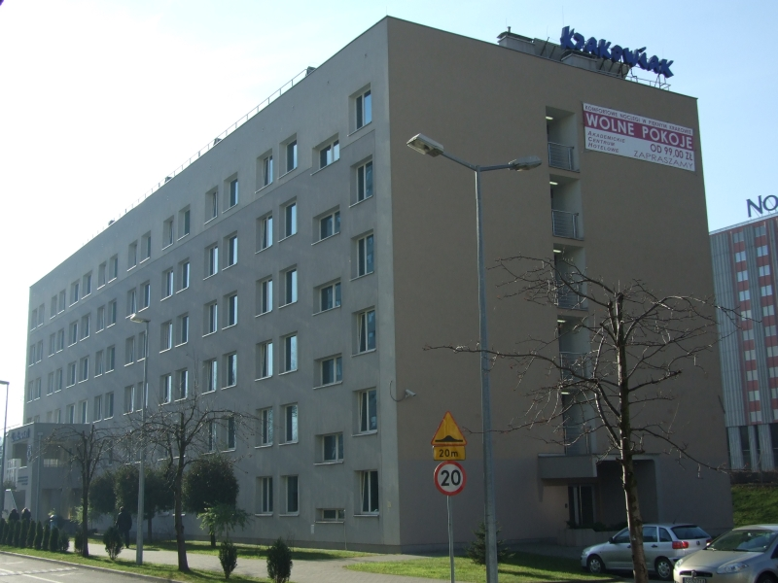
2) Dom Studencki Krakowiak
Armii Krajowej Street 9
The hostel is located in the western part of Cracow. There is a good bus and tram connection.
Distance from CUE: approximately 20-25 minutes by bus
More info at: http://www.ach.up.krakow.pl/krakowiak,eng

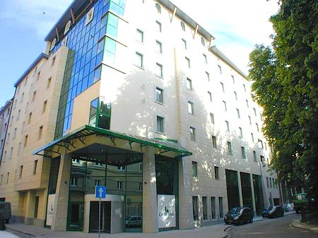
3) Hotel Campanile **
Świętego Tomasza Street 34
The hotel will allow you to feel the atmosphere of Krakow’s Old Town. It is located nearby to the main square (400 meters away) and the UNESCO heritage site. St. Mary’s Church, the Wawel Castle, the Cloth Hall, the underground of the Market Square and other attractions are easy to reach.
Distance from CUE: approximately 25 minutes walk/approximately 5-10 minutes by tram
You can find more at: www.campanile.com/en/hotels/campanile-cracovie-krakow

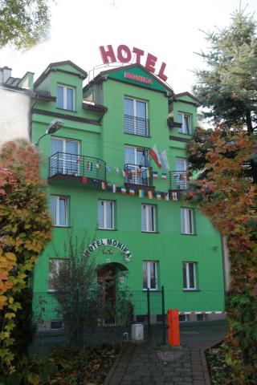
4) Hotel Monika **
Mariana Langiewicza Street 6
The hotel is located nearby 29 Listopada alley. It takes approximately 10 minutes to reach the railway station, bus stations and Galeria Krakowska.
Distance from CUE: approximately 25 minutes walk/approximately 5 minutes by bus
More at: http://www.hotelmonika.pl/

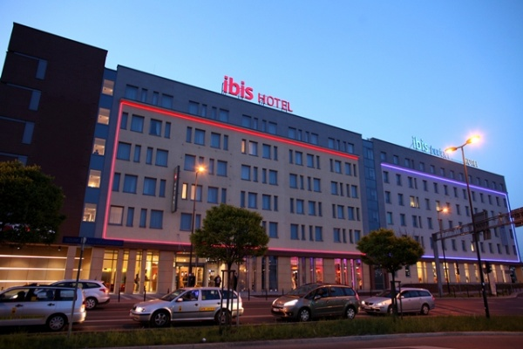
5) Hotel Ibis **
Pawia Street 15
The hotel is located in the heart of Krakow, not far away from the railway station and the Old Town.
Distance from CUE: approximately 15-20 minutes walk
To find out more, please enter the website: www.ibis.com/gb/hotel-7161-ibis-krakow-stare-miasto/index.shtml

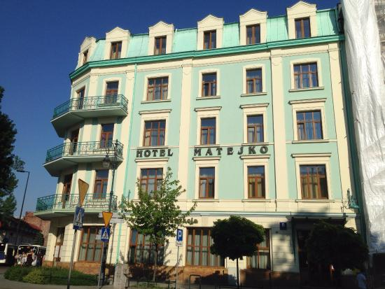
6) Hotel Matejko ***
Jana Matejki Square 8
The hotel lies in the centre of Krakow. The hotel provides rooms suited for handicapped guests.
Distance from CUE: approximately 15-20 minutes walk
More at: www.matejkohotel.pl

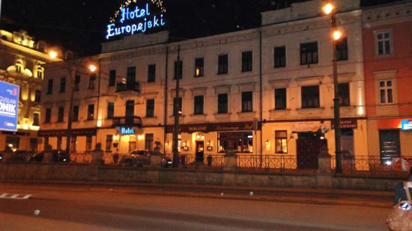
7) Hotel Europejski ***
Lubicz Street 5
Hotel Europejski is located in central Krakow, not far away from the Main Market Square and the railway station. You can also reach easily the UNESCO site of the city.
Distance from CUE: approximately 15-20 minutes walk
For further information, please enter the website: www.he.pl/en

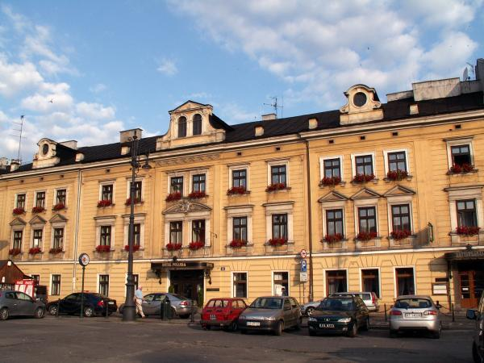
8) Hotel Pollera ***
Szpitalna Street 32
The Pollera Hotel was estabilished in 1834. Nearby the hotel, there is the communication centre of the city – railway and bus stations, and an important public transport junction, as well as one of the largest shopping centres – Galeria Krakowska.
Distance from CUE: approximately 25-30 minutes walk/approximately 5-10 minutes by tram
More at: www.pollera.com.pl

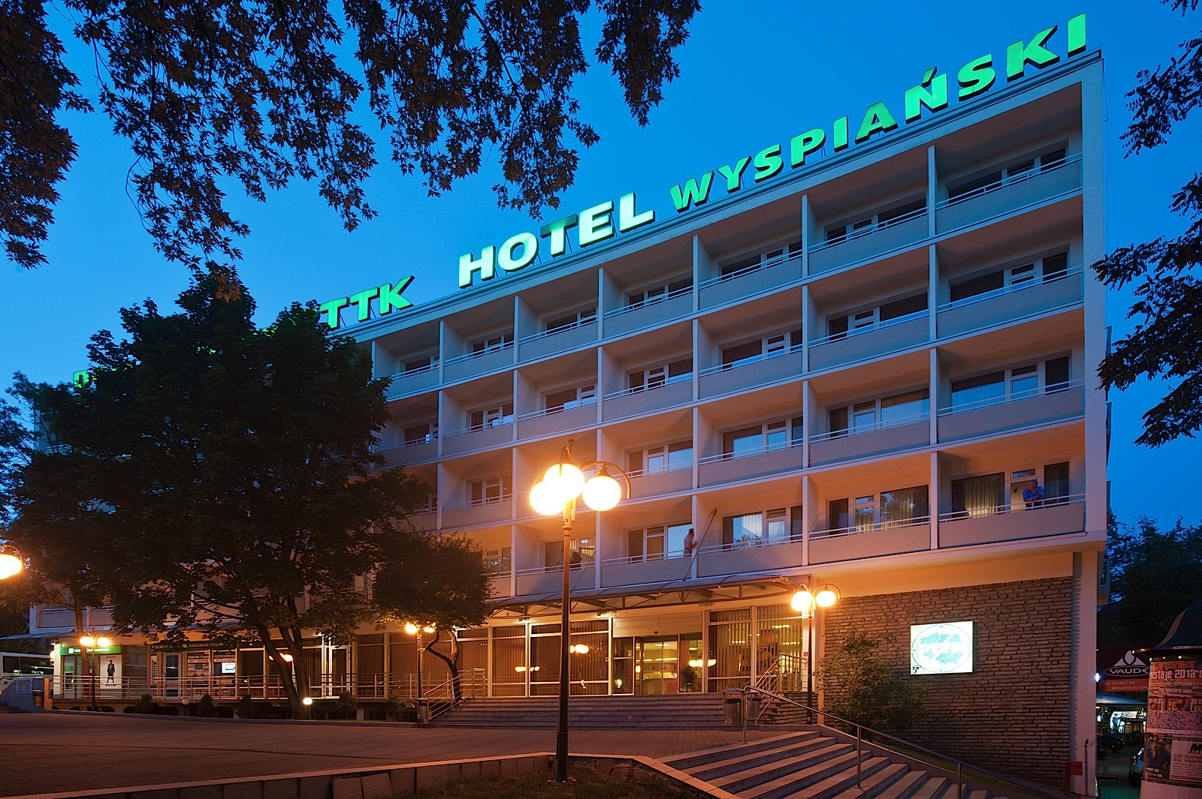
9) Hotel Wyspiański ***
Westerplatte Street 15
The hotel is placed nearby Barbakan, one of the most valuable monuments of medieval Krakow. You can reach the Main Market Square in a couple of minutes.
Distance from CUE: approximately 35-40 minutes walk/approximately 5-10 minutes by tram
For further information about the hotel, please contact: http://www.hotel-wyspianski.pl

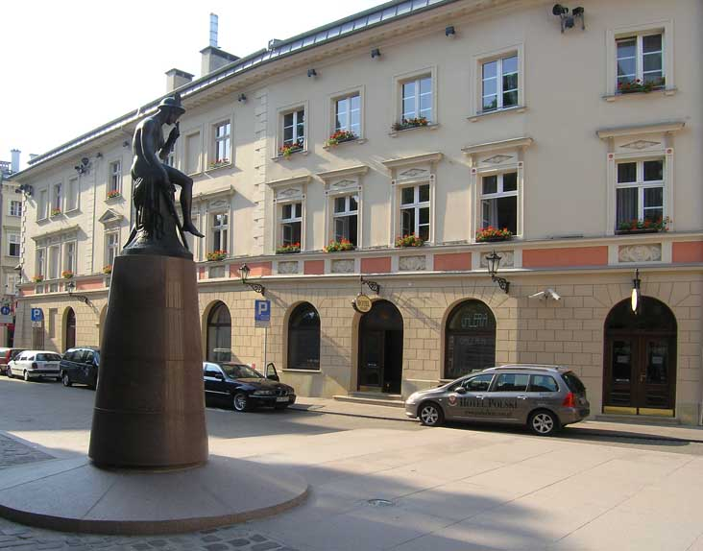
10) Hotel Polski (Pod Białym Orłem)***
Pijarska Street 17
Hotel Polski is situated in the very heart of Cracow, surrounded by the Old Town’s defensive walls, next to St Florian’s Gate. It's very close to Market Square (5 minutes on foot). As for distance to CUE campus it's about 30 minutes by foot or about 5-10 minutes by tram.
Distance from CUE: approximately 30-35 minutes walk/approximately 5-10 minutes by tram
You can find more at: www.podorlem.com.pl

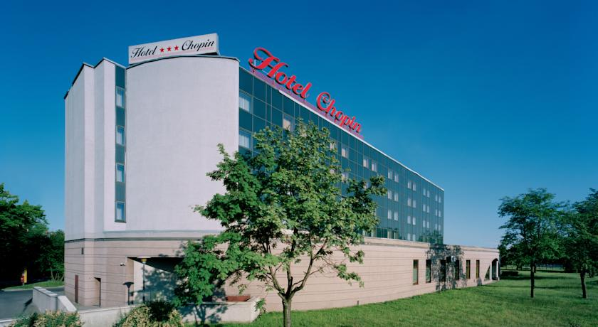
11) Vienna House Easy Cracow***
Przy Rondzie Street 2
We have a corporate agreement with the Chopin Hotel. That means CUE guests can get a discount for rooms.
Chopin hotel is located close to our campus (about 15 minutes on foot), about 900 m away from the Central Railway Station and one kilometer from the Old Town. It's easily accessible by public transport.
Distance from CUE: approximately 10-15 minutes walk
To find out more, please enter the website: www.vi-hotels.com/en/chopin-cracow/

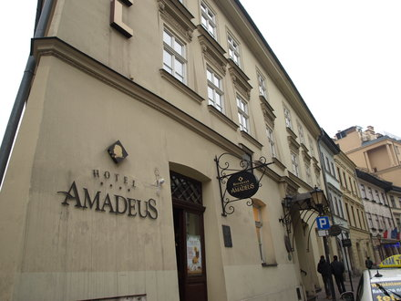
12) Hotel Amadeus ****
Mikołajska Street 20
The Amadeus Hotel is situated close to the centre of the Old Town. Good location enables to reach the city centre and the main railway station within few minutes.
Distance from CUE: approximately 30-35 minutes walk/approximately 10-15 minutes by tram
For further information about the hotel, please contact: www.hotel-amadeus.pl

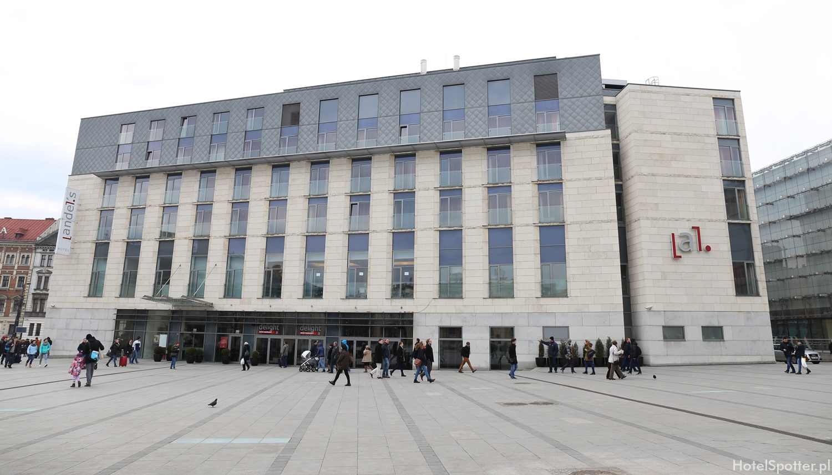
13) Hotel Andels ****
Pawia Street 3
The hotel is placed nearby the biggest shopping centre – Galeria Krakowska. You can reach easily the railway station, bus/tram stations and the Old Town.
Distance from CUE: approximately 10-15 minutes walk
More at: www.vi-hotels.com/en/andels-cracow

Apartments and rooms recommended by CUE

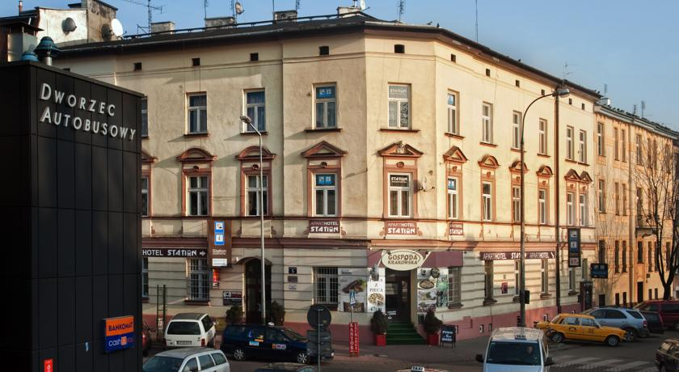
1) Aparthotel station:
Bosacka Street 5
The aparthotel is located in close proximity to places like the railway station, Galeria Krakowska, the Main Market Square etc.
Distance from CUE: approximately 10 minutes walk
More at: http://www.aparthotelstation.pl/en/

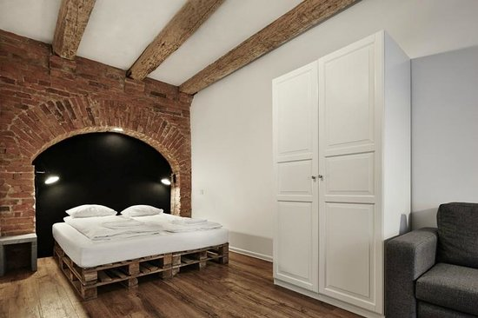
2) Laiko Apartments:
Warszawska Street 3
Apartments are located in the heart of Krakow. You can access all important places quickly – the Main Market Square, St. Mary’s Church, the Wawel Castle, the Cloth Hall, Barbakan, Florianska Street, the railway station and Galeria Krakowska.
Distance from CUE: approximately 20-25 minutes walk
To find out more, please enter the website: http://laikoapartments.pl/

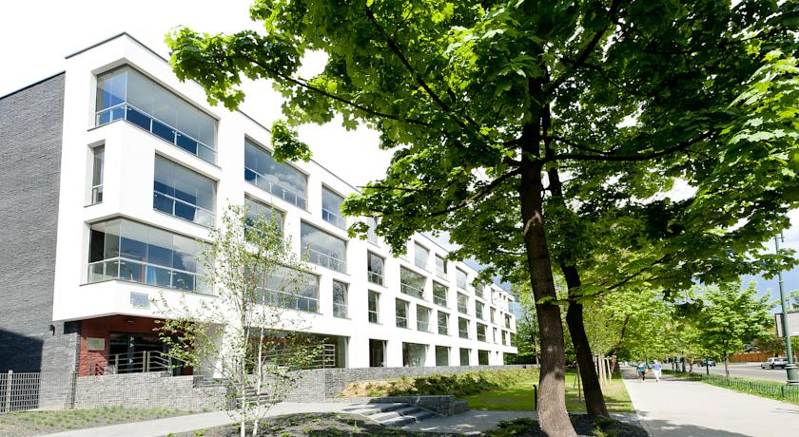
3) Novum Apartments:
Rakowicka Street 20
Exclusive, new apartments that are located next to CUE – you only need to cross the road and you’re there.
Distance from CUE: approximately 2-5 minutes walk
For further information, please enter the website http://www.apartamentynovum.pl/en/mieszkania/zarzadzaniewynajmem.html

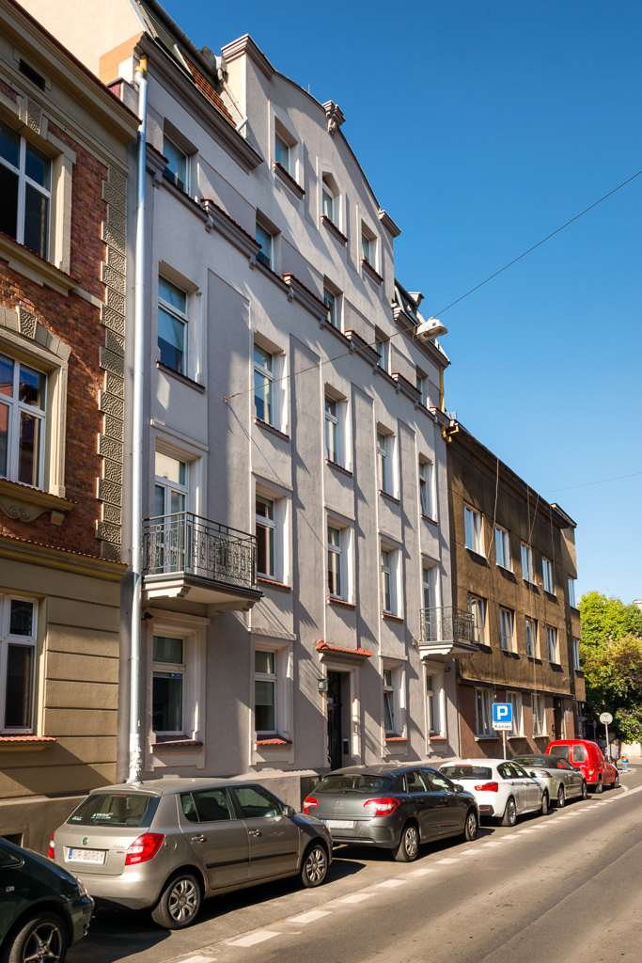
4) Emaus Apartments:
Józefa Ignacego Kraszewskiego Street 14
Emaus apartments are located in the city center, next to the Blonie Park, nearby major tourist attractions such as the Market Square and Wawel Castle.
Distance from CUE: approximately 25-30 minutes by tram or bus
For further information about the hotel, please contact: http://www.emausapartments.pl/

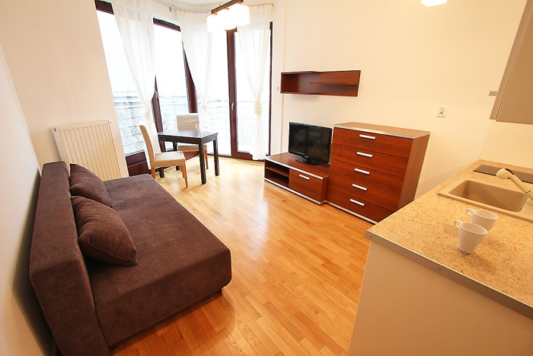
5) Capital Apartments:
Capital Apartments offers a huge variety of apartments to rent in the centre of Krakow.
Locations: Various places nearby the market square and the city centre.
Find out more at: http://www.capitalapart.pl/apartments/search

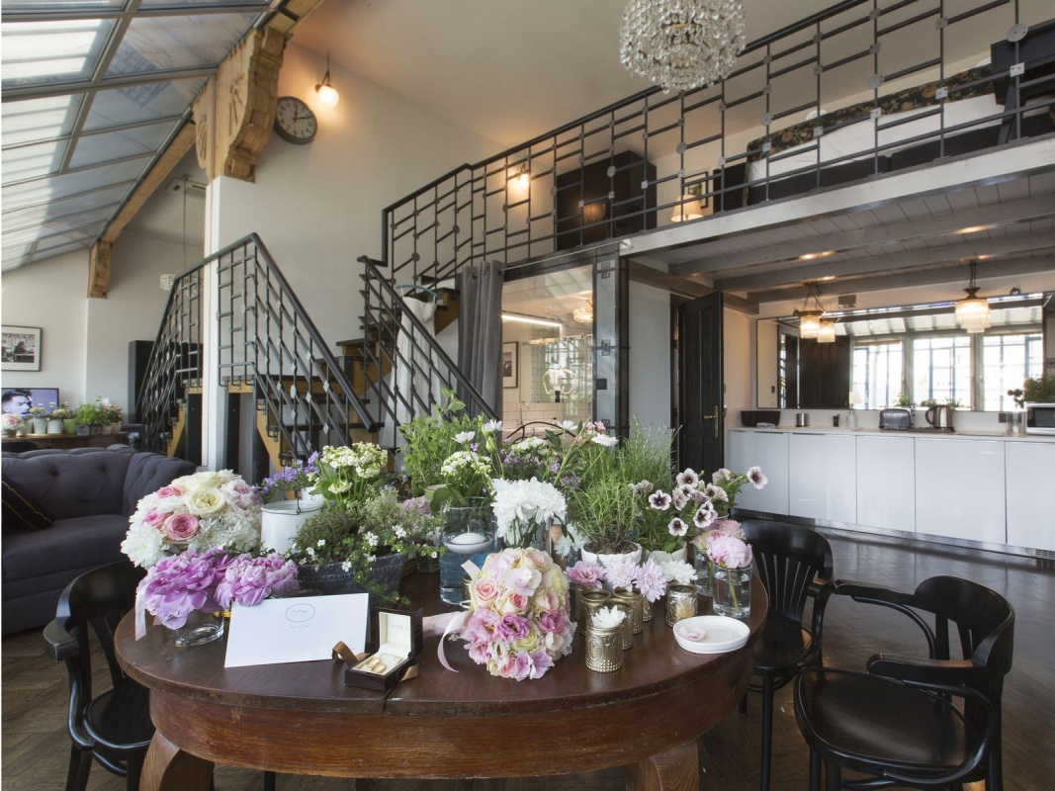
6) Antique Apartments:
Antique Apartments allows you to find available apartments to rent in the centre of Krakow. The location allows you to access all important places quickly.
Locations: Various places nearby the market square and the city centre.
More at: http://www.antiqueapartments.pl/apartamenty

