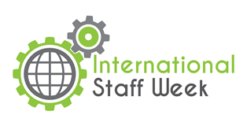

International Staff Training Week
at Wrocław University of Technology
6-10 June 2016

MONDAY, 6.06.2016
Registration
Welcome and introduction
Lunch
City Tour
Welcome dinner
TUESDAY, 7.06.2016
Design Thinking WORKSHOP (Group A) / Crash-course of Polish Language (Group B)
Coffee break
Design Thinking WORKSHOP (Group A) / Crash-course of Polish Language (Group B)
Lunch
Campus presentation
WEDNESDAY, 8.06.2016
Crash-course of Polish Language (Group A) / Design Thinking WORKSHOP (Group B)
Coffee break
Crash-course of Polish Language (Group A) / Design Thinking WORKSHOP (Group B)
Lunch
Free time
THURSDAY, 9.06.2016
All day trip around Lower Silesia region
FRIDAY, 10.06.2016
Bye – bye meeting and evaluation

Participation fee: 150 Euro
Participation fee covers:
- Design Thinking WORKSHOP
- Crash-course of Polish Language
- City Tour
- All day trip around Lower Silesia region
- Welcome dinner
- Lunches (from Monday to Thursday)
- Coffee breaks

