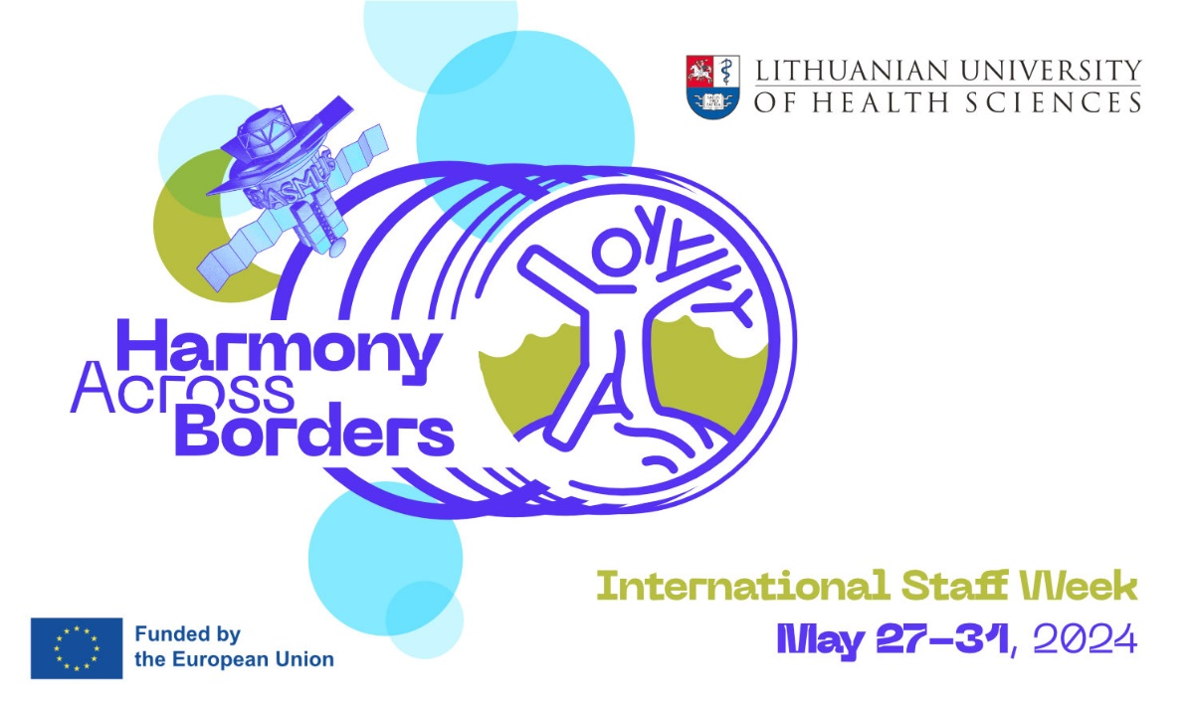
International Week (IW) is mostly designed for teachers, colleagues from International Offices (priority), also support services dealing with international students & cooperation, exchange programmes and EU projects. Lectures will be appreciated in study programmes in the fields of Medicine, Odontology, Pharmacy, Lifestyle Medicine, Management of Public Health, Psychology, Nursing, Occupational Therapy, Physiotherapy, Veterinary Medicine, Animal Science.

Programme will focus on INCLUSION, EQUAL OPPORTUNITIES, GOING GREEN, DIGITAL SERVICE DESIGN, PRO-ACTIVE DEVELOPMENT OF SOCIALLY RESPONSIBLE COMMUNITY.
In addition to international teaching experience, an engaging schedule of face-to-face activities will offer a wide variety of presentations, lectures, and insights on University’s everyday life. 5 days of great experience is guaranteed including:
- topics of internationalization,
- spheres of science & research,
- themes of health for all & healthy lifestyle counseling,
- cultural exchange programme,
- workshops, networking & socializing.
Visit to IW may be formalized as ERASMUS+ Mobility Exchange. For Teaching visits there will be opportunities to combine teaching activities and participation in IW.

Fees. There is no participation fee. All events will be held face-to-face in Kaunas, Lithuania.
Certificates. All participants will be awarded Certificates of Attendance.
Registration. Please fill in on-line registration form here. The deadline for registration - April 30th, 2024.
Max. of 40 participants will be selected for participation. Max. 2 persons from one institution.
Do you have any questions? Please contact us: staffweek@lsmu.lt

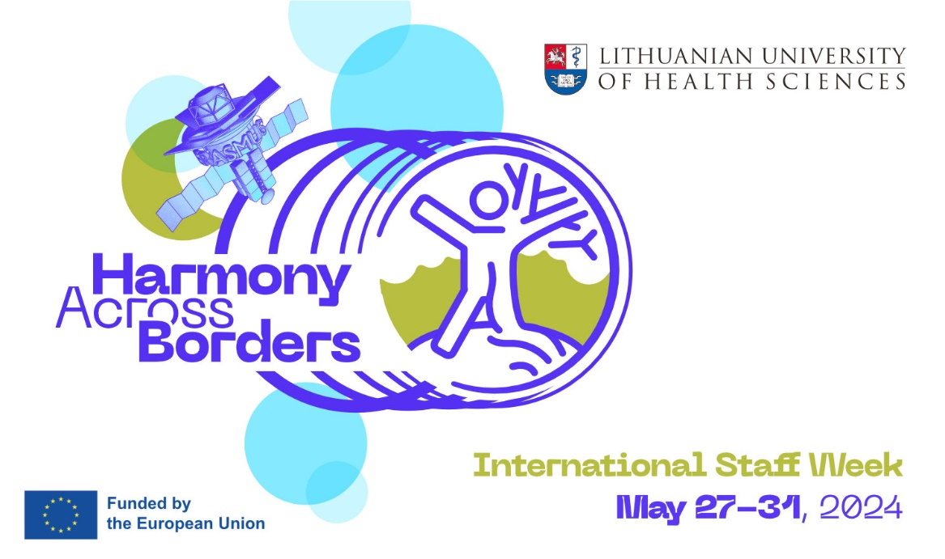

Provisional Programme

Day 1
Morning: Welcome to LSMU (presentations, facts, discussions, workshops)
Afternoon: Get Together Dinner

Day 2
Morning: LSMU guided Campus Tour - Simulation, Innovation, Research & Clinical Practice integrated
Afternoon: Teaching or Training activities at LSMU (lectures, workshops, networking)

Day 3
Morning: Teaching or Training activities at LSMU (lectures, workshops, networking)
Afternoon: Acquaintance with Local Cuisine (cultural workshop)

Day 4
Morning: Teaching or Training activities at LSMU (lectures, workshops, networking)
Afternoon: Explore Kaunas (guided tour)

Day 5
Morning: Lithuanian Tradition at a Glance (outbound excursion with lunch)
Afternoon: Certificates & Goodbyes

