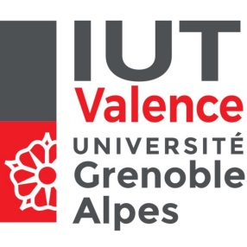
IUT de Valence
Relations Internationales
B.P. 29
26901 VALENCE cedex 9

ERASMUS INTERNATIONAL WEEK 2018

December 3rd-7th

PROVISIONAL PROGRAMME

Monday 3rd | Tuesday 4th | Wednesday 5th | Thursday 6th | Friday 7th
11am  Welcome to IUT Valence  (a presentation and visit of IUT Valence;getting to know one another) | 9:30 am to 12:30 pm  Guest lectures | « A Grand Day Out » = full day excursion*  Discovering local historical and cultural heritage | 8:00 am to 11:00 am  Guest lectures | Free**
12:30 pm  Buffet-lunch* | 12:30 pm  Lunch* at Aire Restaurant | 12:30  Lunch* | 12:30 pm  Buffet-Lunch*
2 pm  A guided tour of the city of Valence  Welcome at Valence town-hall | Free | Suze-la-Rousse  Visit of the Château/Museum  Wine-tasting session…  Workshop ‘sustainable tourism and local economic development’ | 1:30 pm  International student fair  (presentation of partner universities)  7 pm  Formal closing dinner * | Free

*offered by IUT Valence
** The festival of ligths – « Fête des Lumières » is a major visual arts festival takes place in Lyon from 6-9 December 2018. Lyon is just 30’ away from Valence by train.

