PRELIMINARY AGENDA

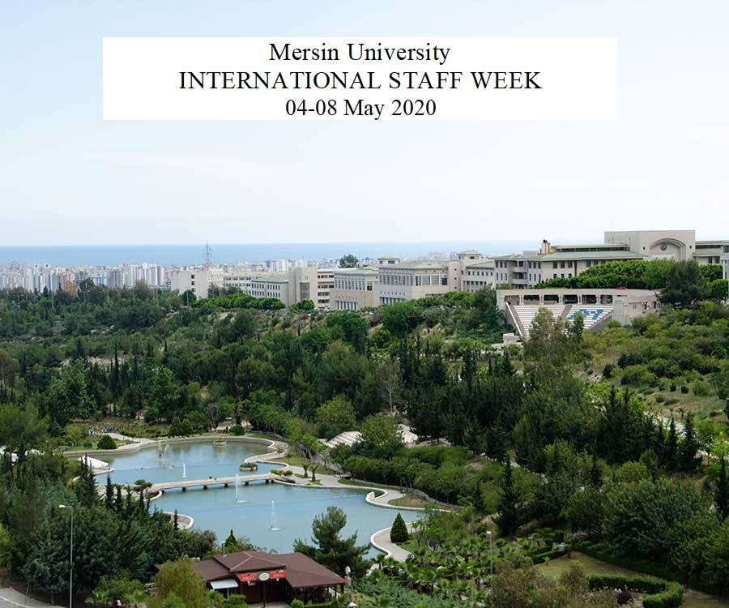

Contact:

Duygu SUMER (Ms.)
Banu ES YILMAZ (Ms.)

erasmusmersin@gmail.com

Mersin University
Dis Iliskiler Sb. Mud., Yenisehir Kampusu,
33169, Yenisehir, Mersin,
Turkiye
Tel: +90 324 3610001 (Ext.12274, 12275. 12277, 12975)
Fax: +90 324 3610103

MERSIN UNIVERSITY
INTERNATIONAL WEEK
4– 8 May 2020

Monday, May 4
13.00-13.30 | Registration of participants
13.30-14.15 | Welcome speech and cultural introduction of Turkey and Mersin
14.15-14.30 | Coffee Break
14.30-15.30 | Introduction to Turkish Language
16.00-18.00 | Mersin guided city tour
Evening | Free time

Tuesday, May 5
10.00-11.00 | Presentations of Participating Institutions- I
11.00-11.15 | Coffee break
11.15-12.30 | Presentations of Participating Institutions- II
12:30 | Lunch at Campus Vadi Restaurant
14:30-16.00 | Campus tour
19:00 | Welcome Dinner
Wednesday, May 6
10:00 | International Education Fair
12:00-13:00 | Lunch break
13:00 | Guided Tour to Kızkalesi (Maiden Castle)
19:00 | Free Evening
Thursday, May 7
09.30 | Erasmus Workshop ( the topics will be determined later)
10.15 | Coffee break
10.30 | Erasmus Workshop
12.00 | Lunch
13.00 | Meeting Faculties /Departments - Bilateral agreements
19.00 | Gala Dinner and Closing Ceremony
Friday , May 8
10.00 | Meeting Faculties /Departments - Bilateral agreements

