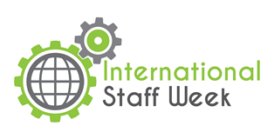

INTERNATIONAL STAFF TRAINING WEEK
29.05.2017 – 02.06.2017

MONDAY, 29.05
12:00–12:30 | Registration
12:30–14:00 | Welcome and introduction
14:00–15:00 | Lunch
15:00–17:00 | City tour
19:00 | Welcome Dinner
TUESDAY, 30.05
09:00–11:00 | Training – Self-presentation (part I)
11:00–11:30 | Coffee break
11:30–13:30 | Training – Sef-presentation
13:30–14:30 | Lunch
14:30-16:00 | Polish language course (part I)
16:30-18:00 | Cultural tour
WEDNESDAY, 31.05
09:00–11:00 | Training – Self-presentation (part II)
11:00–11:30 | Coffee break
11:30–13:30 | Training – Self-presentation
13:30–14:30 | Lunch + Tastes of the World*
14:30-16:00 | Polish language course (part II)
THURSDAY, 01.06
07:45–19:00 | All day trip around Lower Silesia region  - Old Mine Science and Art Centre in Wałbrzych http://www.starakopalnia.pl/english/  - Lunch  - Książ Castle http://www.ksiaz.walbrzych.pl/en/turystyka
FRIDAY, 02.06
9:30-10:30  10:30-12:00 | Farewell meeting & Coffee break  Job shadowing

*Please bring along traditional snacks from your country/region to share with other participants.

