7th AUBG Erasmus Teaching and Training Week
Tentative Program

Monday April 8th, 2019 | Tuesday April 9th, 2019 | Wednesday April 10th, 2019 | Thursday April 11th, 2019 | Friday April 12^{ve}, 2019
10.00-10.20-Registration  AUBG Campus, Aspire, ABF  10.20-10.30-Welcome address by the President’s Office  AUBG Campus, Room 6306, ABF  10.30-11.00 -Warm-up workshop  AUBG Campus, Room 6306, ABF  11.00-11.30- Presentation about Erasmus+ program at AUBG  AUBG Campus, Room 6306, ABF  11.30-13.00-European Gastronomy Fair of traditional food and drinks presented by the participants  AUBG Campus, Room 6306, ABF  13.00-15.00-Guided Tour of AUBG Skaptopara Campus and Main Building  15.00-17.00  Guided tour of Blagoevgrad  19.30-21.00- Cultural program-Unique chance to enjoy the traditional Bulgarian songs and dances of AUBG Female Folklore Ensemble “ Svetlina” and AUBG Folklore Dance Ensemble “Samodiva” AUBG Campus, Room 6306, ABF | 10.00-10.30- AUBG Library presentation and tour AUBG Campus, BAC, Library  10.30-12.30- Erasmus Fair during which each participant will have the chance to present his/her home University to the others and provide some information materials. The event is expected to serve as a basis for further bilateral agreements between the participating institutions  AUBG Campus, Room 6306, ABF  12.30-13.30- Lunch ( at your own expenses )  13.30-14.00 Presentation about AUBG - AUBG Campus, Room 6306, ABF  14.00-16.30- Bulgarian language and culture workshop  AUBG Campus, Room 6306, ABF  16.30-17.00 Green Initiative  19.00-21.00- Interactive workshop- traditional Bulgarian cuisine  AUBG Campus, Room 6306, ABF  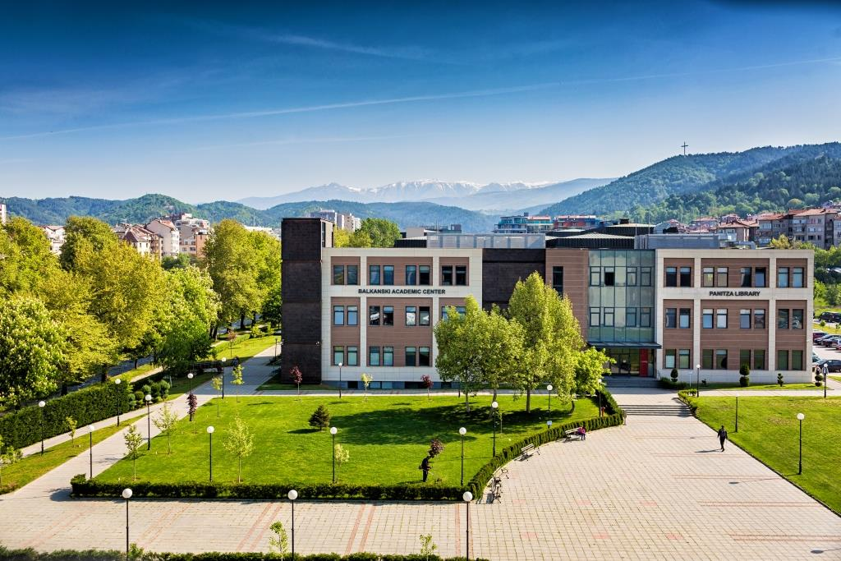 | 9.00 – 17.00  Interactive workshop – Bulgarian traditions and culture presented in Gorno Draglishte - where participants can feel the unique atmosphere of the countryside, cook and try traditional Bulgarian food, learn more about Bulgarian traditions, folk dances and songs.  On their way back the participants will visit the church “ St. St. Theodor Tiron and Theodor Stratilat “ in Dobarsko. It was built in 1614 by rich and well-educated people. Its authentic architecture and unique murals and icons make it one of the most memorable pieces of Bulgarian art.  Price for transportation approximately 15 Euros per person.  Price for meals approximately 10 Euros per person  19.30- 21.00 Honors Convocation – (annual celebration where undergraduate students are recognized for their distinguished academic achievements ) followed by Reception  AUBG Campus, DR Carl Djerassi Theatre Hall, ABF | 10.00-12.00  Individual Meetings with different AUBG offices/departments  AUBG Campus  12.00-13.00- Lunch ( at your own expenses )  13.00-14.00- Interactive workshop – make a traditional Bulgarian “Martenitsa” by yourself  AUBG Campus, Room 6306, ABF  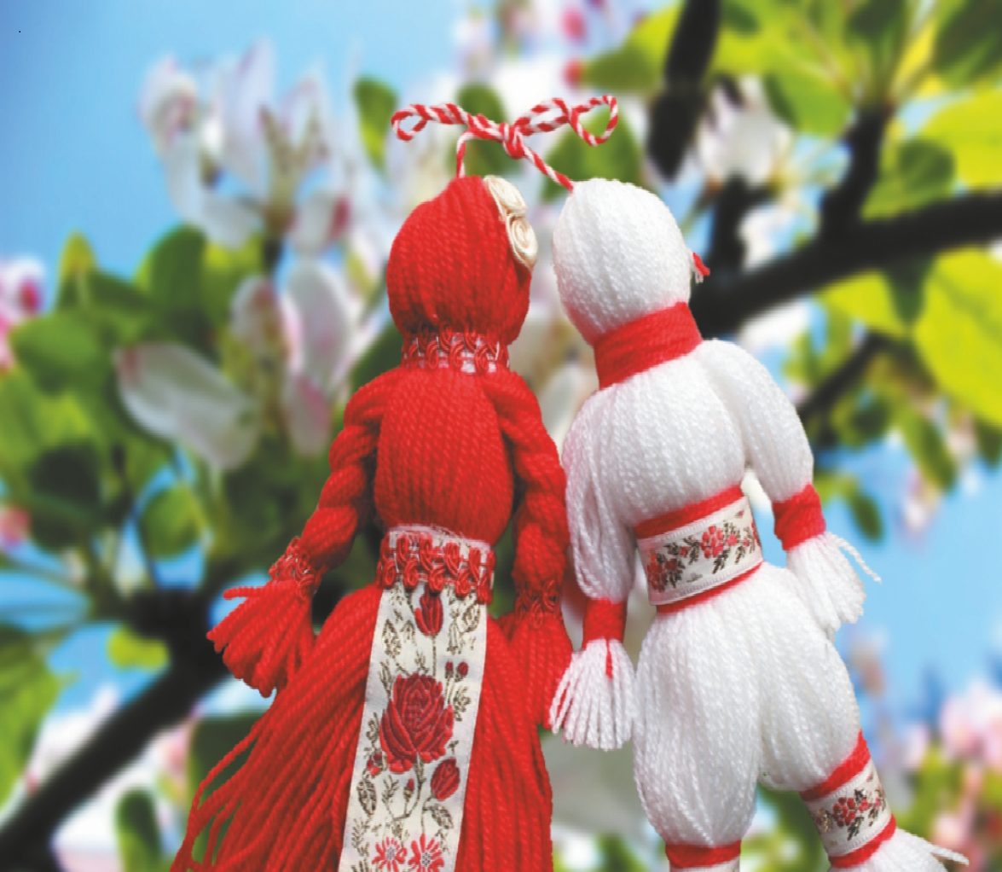  14.00-15.15- World café: Erasmus+ best practices and new opportunities for universities  AUBG Campus, Room 6306, ABF  15.15-16.00- Presentation about summer schools and programs at AUBG  AUBG Campus, Room 6306, ABF  16.00-16.30- Presentation about AUBG Choir  AUBG Campus, Room 6306, ABF  19.30 – 21.30- Exchange evening – Students will share their impressions from a foreign country they have visited while they were on exchange  AUBG Campus, BAC, Library – first floor; | 9.30-10.30  Closing the 7th Erasmus staff training week, Certificate awards  AUBG Campus, Room 6306, ABF  10.30-15.30  Trip to Rila Monastery (optional) -  price for transportation approximately 15 Euros per person  The Rila Monastery was founded in the 10th century by St John of Rila, a hermit canonized by the Orthodox Church. His ascetic dwelling and tomb became a holy site and were transformed into a monastic complex which played an important role in the spiritual and social life of medieval Bulgaria. Destroyed by fire at the beginning of the 19th century, the complex was rebuilt between 1834 and 1862. A characteristic example of the Bulgarian Renaissance (18th–19th centuries), the monument symbolizes the awareness of a Slavic cultural identity following centuries of occupation.

