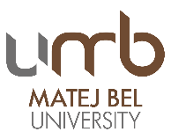
1st MBU STAFF WEEK
Preliminary program
Monday, 4.9.2017
- Arrival
- Dinner organized at one place
Tuesday, 5.9.2017:
- Welcome speech
- Introducing Slovakia
- Introducing Matej Bel University in Banská Bystrica, study offer
- Introducing your Universities, your PPT presentations with max 5 slides
- Lunch
- Tour through the historical part of the town of Banská Bystrica
Wednesday, 6.9.2017
- Workshops:
  - library: 1 hour - MBU University Library and its activities: Open Access & Predator publishing, volunteering programme, social media
  - projects: 1 hour – University center for projects, MBU attending international projects; Horizon 2020, Erasmus+ KA2 and others

- Lunch
- Erasmus+ programme discussion: documentation, preparation, organisation, summarisation, partner cooperation, bilateral agreements, foreign office, acceptance of foreigners, promotion on Facebook and other social media
- Špania dolina – visit http://www.spaniadolina.sk/?lang=en
Thursday, 7.9.2017
- Highlights of our faculties – visit our faculties
- Individual meetings, science
- Dinner with the rector of our university
- Folk ensemble “Mladosť”

Visit our faculties
9:00 – 11:00 AM Faculty of Law, http://www.prf.umb.sk/en/, Komenského street 20

- Presentation of Faculty and its premises
- Visit our court
- Meet the Dean
- Faculty and its activities, bilateral agreements possibilities

9:00 – 11:00 AM, Faculty of Education, https://www.pdf.umb.sk/en/, Ružová street 13

- Presentation of Faculty and its premises
- Chamber orchestra MLADOSŤ

- Workshops – discussion:
  - service learning
  - inclusive education of socially excluded groups
  - adult education
- Exhibition of students’ works
- Visit to a private basic school „Škola u Filipa“ at our premises
- Visit to a dormitory ŠD5

9:00 – 11:00 AM, Faculty of Political Science and International Relations, http://www.fpvmv.umb.sk/en/, Kuzmányho street 1

- Presentation of Faculty and its premises
- Presentation of the main activities in science, research and studies
- The crisis management center at MBU

9:00 – 11:00 AM, Faculty of Economics, http://www.ef.umb.sk/indexe.asp, Tajovského street 10

- Presentation of Faculty and its premises
- Double degrees at our faculty
- Quick language course – Slovak – basic phrases
- Seminar on intercultural communication – EN
- Talent research center

11:00 – 13:00 AM, Faculty of Natural Sciences, http://www.fpv.umb.sk/en/, Tajovského street 40

- Presentation of Faculty and its premises
- Research areas of our departments, study programmes
- Common general discussion with the representatives of our departments
- Visit our specialized premises
  - modern laboratories at the department of Chemistry; professional commentary in the context of research activities
  - discussion with the department of biology and ecology in the atrium of the building at the Rehabilitation station for disabled animals (storks)
  - department of mathematics, research areas and results reached, meet the team of professionals
  - presentation of model examples of research at the department of geography and geology
  - presentation of our scientific areas in the context of Environmental Management

11:00 – 13:00 AM, Faculty of Arts, http://www.ff.umb.sk/en/, Tajovského street 40
- Presentation of Faculty and its premises: swimming pool, sport areas, accommodation at our dormitories
- Erasmus Student Network UMB office
- Project cooperation, mobilities, scholarships, doctoral studies, habilitations, inaugurations
- Marketing activities
- Simulated conference from the perspective of speaker and interpreter
- Lecture: Themen des osterreichischen Gegenwartsromans (in German language)
- Presentation of study programme: translation and interpreting – Spanish, French, Italian
- Presentation of study programme: Russian language and the history of Russia in Arts literature
- Presentation of the Center of Polish language and culture (in English language; in Russian language; in Polish language)

Friday, 8.9.2017
- departure, free programme – Radvan’s fair

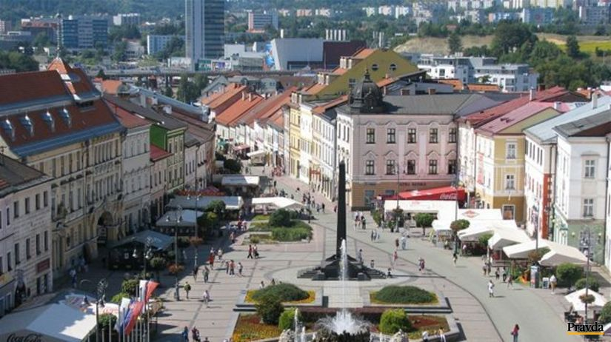

*********************************************************************************
Radvan's fair (“Radvanský jarmok“) Banská Bystrica 2017 – 360th year of the Craft Market
07.09.2017 - 10.09.2017 on the main square
http://www.folklorfest.sk/6227-radvansky-jarmok-banska-bystrica-2017-360-rocnik/
Year 2017
360th Radvan’s fair,
20th Craft Market,
4th Meeting of Slovaks living abroad
Radvan's fair was one of the most famous and largest fairs in the whole Upper Hungary. It was originally held in the town of “Radvaň” near Banská Bystrica. The most complete and beautiful copy of Radvan's fair was left in Gustav Kazimir Zechenter Laskomersky’s childhood memories.
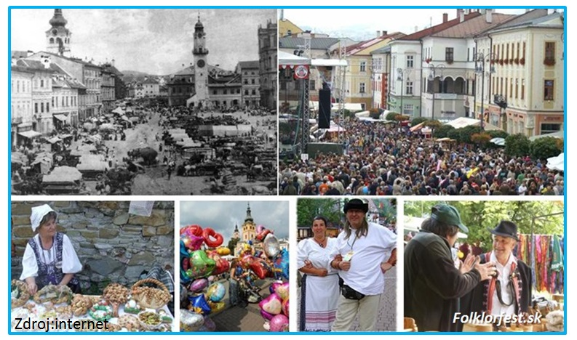
It describes how fairsmen from Novohrad, Hont, Podpoľanie and from the remote "Lower Grounds" came bringing their products - pottery, garbage, weaving, cheese products and carvings.
Radvan's fair was different from other fairs on the territory of Slovakia. Boys, men would slap girls’ buttocks with a wooden ladle. The habit of slapping girls remains more or less until today. Unfortunately, why this habit characterized the Radvan's fair historians cannot explain with certainty even today.

**********************************************************************************

