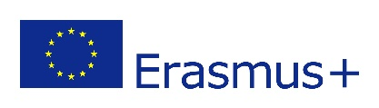
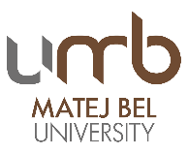
2nd MBU STAFF WEEK
"Language as a communication tool in the academic environment"
Preliminary Programme
Tuesday, 4.9.2018:
- Arrival
Wednesday, 5.9.2018:
8:00 AM - Rectorate, Národná 12, Banská Bystrica
- Registration in the meeting room Nr. 1, Rector Office, Národná 12
- Welcome speech
- Introducing Slovakia
- Introducing Matej Bel University in Banská Bystrica, study offer
- Coffee break
- Introducing your Universities, your PPT presentations with max 5 slides
- Slovak as a foreign language – short course
- Lunch with UMB rector – Slovenská reštaurácia Banská Bystrica – on invitation
- Workshop: Erasmus+ projects
- Workshop: Library
- Leisure time activity – guided tour
Thursday, 6.9.2018
8:00 AM – 14:00 PM Faculty of Arts, http://www.ff.umb.sk/en/, Tajovského street 40

- Presentation of Faculty and its premises - EN
- Workshop A) “European Day of Languages” - EN
(A few facts about languages; talk to me; animal sounds; favourite words; same word – different meaning …)
- Workshop B) “European Day of Languages” - EN
(Idioms of the world; unique words; language quiz …)
- Workshop C) “European Day of Languages” – EN
(Lost in translation)
- Individual Lunch
- Discussion. Summary from work in workshops. - EN
- Leisure time activity – guided tour
Friday, 7.9.2018
9:00 – 11:30 AM, Faculty of Political Science and International Relations, http://www.fpvmv.umb.sk/en/, Kuzmányho street 1

- Presentation of Faculty and its premises – EN
- Intercultural intelligence as a means of mediation – EN
- Workshop A) Colleges’ and students’ interests associations as an instrument for the internationalization of education – FR
- Workshop B) Intercomprehension of Romance languages – ES
- Workshop C) Media competence – who needs media and what is their role in current politics – DE

- 11:30 – 12:30 Individual lunch
12:30 Meeting point: Restaurant Hotel Národný dom close to Rectorate, transport to the Faculty of Economics, you will be accompanied by an employee

12:30 – 16:00 PM, Faculty of Economics, http://www.ef.umb.sk/indexe.asp, Tajovského street 10

- Presentation of Faculty and its premises - EN
- Double degrees at our faculty EN
- Seminar on intercultural communication: The Role of English in Intercultural communication – EN
- Round table – language competences in the academic environment
- Talent research center EN
- Self-study center EN

- FAREWELL SPEECH, CONFIRMATIONS

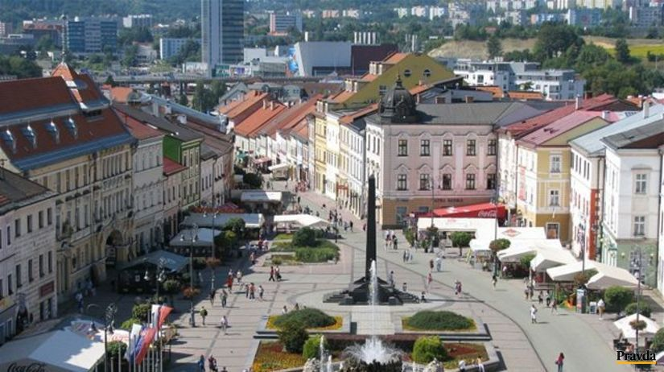

*********************************************************************************
Radvan Fair (“Radvanský jarmok“) Banská Bystrica 2018 – 361th year of the Craft Market
07.09.2018 - 09.09.2018 on the main square
http://www.folklorfest.sk/7551-radvansky-jarmok-banska-bystrica-2018-361-rocnik-/
Year 2018
361th Radvan Fair,
21th Craft Market,
5th Meeting of Slovaks living abroad
The Radvan Fair was one of the most famous and largest fairs in all of Upper Hungary. It was originally held in the town of “Radvaň” near Banská Bystrica. The most complete and beautiful account of the Radvan Fair can be found in the childhood memoirs of author Gustav Kazimir Zechenter Laskomersky.
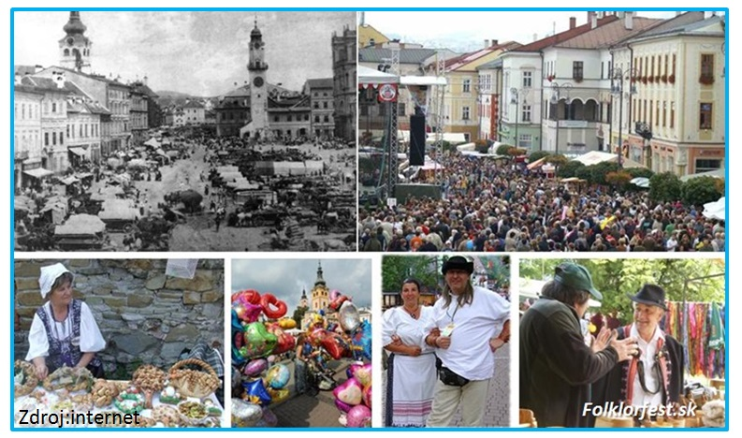
It describes how artisans from Novohrad, Hont, Podpoľanie and the remote "Lowlands" of Hungary came bringing their products – pottery, leather goods, weaving, cheese products and carvings.
The Radvan Fair was different from other fairs in what is now Slovakia – boys and men would slap girls’ buttocks with a wooden ladle. The habit of slapping girls with spoons has remained more or less to this day. Unfortunately, why this habit became a tradition at the Radvan Fair is something historians cannot explain with certainty even today.
**********************************************************************************

