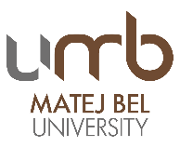
3rd STAFF WEEK
"Protection - Nature Protection, Human Rights Protection, Child Protection and even more"
Preliminary Programme
Tuesday, 3.9.2019:
8:00 AM – 3:00 PM, Rectorate building, Národná street 12, Banská Bystrica
- 8:00 Registration in the meeting room Nr. 1, Rector Office, Národná 12
- 8:30 Welcome speech
- 8:35 Introducing Slovakia
- 8:50 Introducing Matej Bel University in Banská Bystrica, study offer
- 9:00 Introducing your Universities, your PPT presentations with max 5 slides
- 11:15 Slovak as a foreign language – short course
- 12:00 Lunch with UMB rector – on invitation
- 13:30 Workshop: Erasmus+ projects
- 14:00 Workshop: Library
- 16:00 Leisure time activity – guided tour around the town, meeting point Rectorate
Wednesday, 4.9.2019:
9:00 AM – 11:45 AM Faculty of Natural Sciences, http://www.fpv.umb.sk/en/, Tajovského street 40,
Human protection against chemical abuse, Environmental Protection, Animal Protection

- 9:00 Presentation of the Faculty and its premises
- 9:15 Workshop: Chemistry as a powerful tool for public protection and security.
(Experimental workshop on how to reveal an unwanted drug in your drink in real conditions. Spiked drinks testing in the chemistry lab for free )
- 9:45 Lecture: Environmental risks, contamination of landscape components and their solutions (remediation of contaminated landscape using active and passive methods of remediation and possibilities of minimizing environmental risks)
- 10:30 Workshop: Taking care of injured animals (especially vertebrates – birds and mammals) in the Faculty Animal Rescue Centre (interior and exterior activity)
- 11:30 Final summary
Thursday, 5.9.2019
9:00 AM – 11:30 PM Faculty of Education, https://www.pdf.umb.sk/en/, Ružová street 13
Child Protection

- 9:00 Presentation of Faculty and its premises
- 9:30 Workshop on the projects realized in the area of preparation of helping professions and on possible cooperation
- 11:00 Visiting the schools in areal of the FE (elementary and secondary school)

- 14:00 Leisure time activity – guided tour, meeting point Rectorate
Friday, 6.9.2019
9:00 AM – 11:30 PM, Faculty of Law, http://www.prf.umb.sk/en/, Komenského street 20
Human Rights Protection

- 9:00 Registration and welcoming of the participants, Introduction of the Faculty of Law
- 9:30 Visit to the faculty premises
- 10:00 Moot court performed by the students of FL on the human rights topic/
- Specialized human rights seminar presented by Dr. Ľubica Saktorová on the World court of human rights (feasibility study) topic

- 11:00 FAREWELL SPEECH, CONFIRMATIONS, Faculty of Law

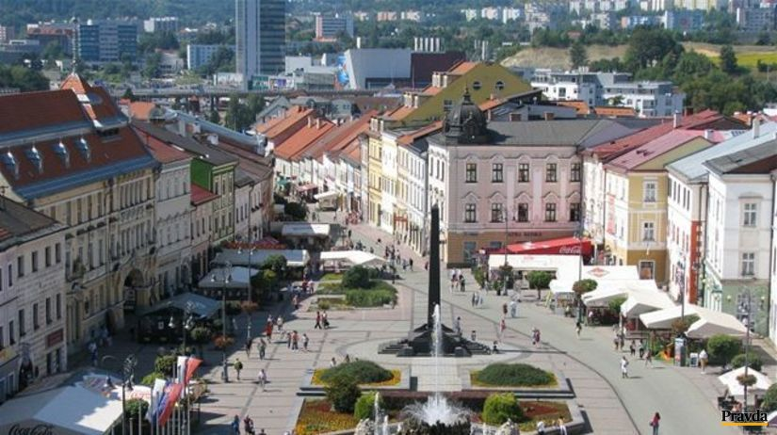

*********************************************************************************
Radvan Fair (“Radvanský jarmok“) Banská Bystrica 2019 – 362nd year of the Craft Market
06.09.2019 - 08.09.2019 on the main square
http://www.folklorfest.sk/7551-radvansky-jarmok-banska-bystrica-2018-361-rocnik-/
Year 2019
362nd Radvan Fair,
22nd Craft Market,
6th Meeting of Slovaks living abroad
The Radvan Fair was one of the most famous and largest fairs in all of Upper Hungary. It was originally held in the town of “Radvaň” near Banská Bystrica. The most complete and beautiful account of the Radvan Fair can be found in the childhood memoirs of author Gustav Kazimir Zechenter Laskomersky.
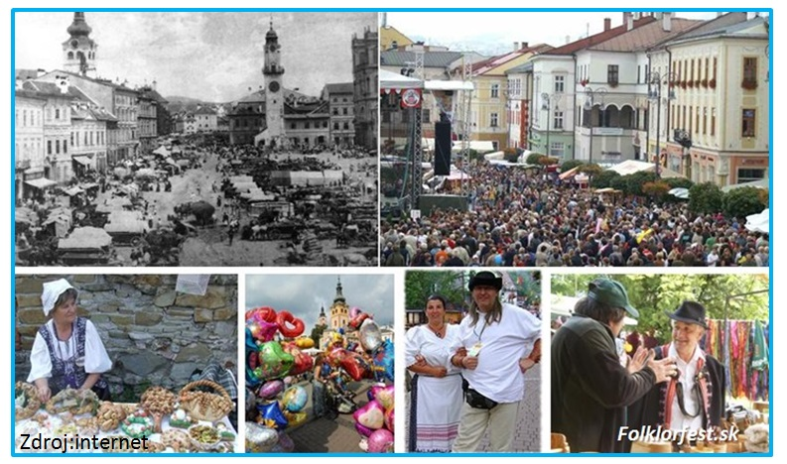
It describes how artisans from Novohrad, Hont, Podpoľanie and the remote "Lowlands" of Hungary came bringing their products – pottery, leather goods, weaving, cheese products and carvings.
The Radvan Fair was different from other fairs in what is now Slovakia – boys and men would slap girls’ buttocks with a wooden ladle. The habit of slapping girls with spoons has remained more or less to this day. Unfortunately, why this habit became a tradition at the Radvan Fair is something historians cannot explain with certainty even today.
**********************************************************************************

