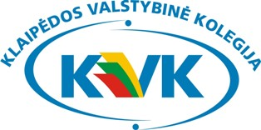

6th INTERNATIONAL WEEK
AT KLAIPEDA STATE UNIVERSITY OF APPLIED SCIENCES

PROGRAMME 2016

25 April (Monday) Jaunystes str. 2, Klaipeda
12:30 Pick up from Hotel
13:00 – 13:30 Presentation of Klaipeda State University of Applied Sciences
13:30 – 15:00 Presentations of Guest Institutions
15:00 – 17:00 Euro Lunch with Lithuanian folklore
Lithuanian traditional food and drinks, music and dance
Guests present their traditional food and drinks

26 April (Tuesday) Faculty of Health Sciences, Dariaus ir Gireno str. 8, Klaipeda
08:40 Pick up from Hotel
09:00 – 09:30 Visiting the departments and laboratories
10:00 – 12:00 International Conference / Lecturing
12:00 – 12:30 Coffee break and Stands by visiting institutions for KVK students
12:30 – 15:00 International Conference / Lecturing
16:00 – 17:00 Guided Tour of Klaipeda Old Town*

27 April (Wednesday) Faculty of Technologies, Bijunu str. 10, Klaipeda
08:30 Pick up from Hotel
09:00 – 10:00 Visiting the departments, laboratories, Center of Applied Sciences of Transport Engineering in the faculty
09.45 – 10.00 10:00 – 11:00 Presentations of Students International Experience of Exchange
11:00 – 12:00 Stands by visiting institutions for KVK students
12:30 – 13:30 Lunch*
14:00 – 15:30 Visiting social partner company / Lecturing
17:30 Dinner*

28 April (Thursday) Faculty of Social Sciences, Jaunystes str. 1, Klaipeda
09:00 Pick up from Hotel
09:30 – 10:00 Presentation of Lithuanian language
10:00 – 11:00 Visiting the departments, Business Practical Learning Enterprise
11:00 – 12:00 Stands by visiting institutions for KVK students
12:30 – 13:30 Lunch* Discussion, Feedback and Results
14:00 – 15:00 Visiting Palanga Rehabilitation Hospital – Ssocial partner of Health Sciences Faculty / Lecturing
15:30 – 16:00 Guided excursion* in Palanga Amber Museum and visiting Palanga Botanical Garden / Lecturing

29 April (Friday)
10:30 Pick up from Hotel
11:15 – 11:40 Ferry boat trip to Dolphinarium (http://juru.muziejus.lt/en/ )
12:00 – 12:40 Dolphin Show*

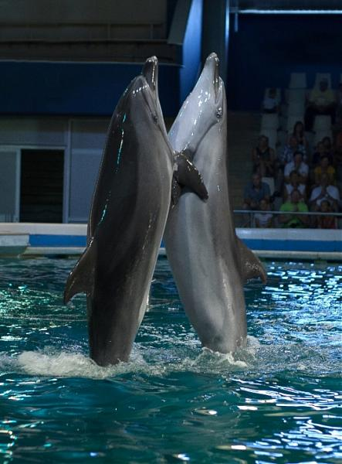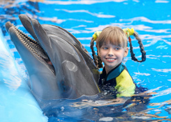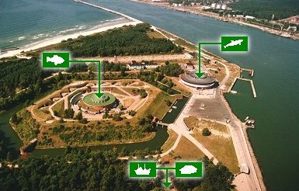

* Financed by Klaipeda State University of Applied Sciences

