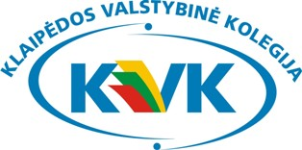

8th INTERNATIONAL WEEK
AT KLAIPEDA STATE UNIVERSITY OF APPLIED SCIENCES

10 April (Monday)
Afternoon: Registration
Welcome speech
Presentation of Klaipeda State University of Applied Sciences
Presentation of Lithuanian language, history and folklore

11 April (Tuesday) Faculty of Health Sciences
Visiting the departments and laboratories
International Conference / Lecturing or training at host department
Lunch break
International Conference / Lecturing or training at host department
Guided excursion of Klaipeda Old Town

12 April (Wednesday) Faculty of Technologies
Visiting the departments and laboratories
Presentations of Students International Experience of Exchange / Lecturing or training at host department
Interactive lunch
Networking session
Dinner

13 April (Thursday) Faculty of Social Sciences
Visiting the departments, Business Practical Learning Enterprise/ Lecturing or training at host department
Interactive Workshop
International coffee break with traditional delicacies from the participant’s countries
Feedback and Results
Networking lunch
Ferry boat trip to Dolphinarium (http://juru.muziejus.lt/en/) / Lecturing
Dolphin Show / Lecturing or training at host department
Return to Klaipeda

14 April (Friday) Individual visits / Lecturing or training at host department

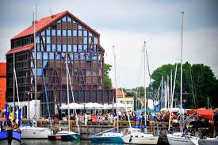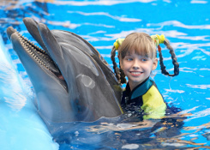

Participation fee is 60 Euro and includes (only for Staff Training):
2 lunches (on Wednesday and Thursday), Dinner (on Wednesday), Coffee breaks,
Guided excursions (on Tuesday and Wednesday), Dolphin Show

