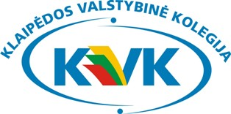

3 ^{rd} ANNUAL INTERNATIONAL WEEK AT KLAIPEDA STATE COLLEGE

„INTERCULTURAL ERASMUS EXPERIENCE: 10 YEARS WITH ERASMUS“

REGISTRATION FORM

First name _______________________________________________
Last name _______________________________________________
Gender _______________________________________________
Position/Academic Title _______________________________________________
Name of Institution/Company ____________________________________________
Postal code, City _______________________________________________
Country _______________________________________________
Phone _______________________________________________
E-mail _______________________________________________
Title of lecture or
Field of interest for training _______________________________________________
I will participate in the excursion on 26 September (Friday) yes □ no □

ARRIVAL AND DEPARTURE INFORMATION

Name of the airport: _________________

Date and time of arrival: __________________

Date and time of departure: __________________

ACCOMMODATION

We recommend you hotel “Ambertone”
Address: Naujojo sodo 1, LT-92118, Klaipeda, Lithuania
Website: http://www.ambertonhotels.com/klaipeda
Location: the city centre

□ I would like to book a single room including breakfast (from €37/night)
□ I would like to book a double room including breakfast (from €37/night)
□ I will book accommodation on my own.

_______________________________________________________________________________
PLEASE RETURN THIS FORM BY E-MAIL TO:
international@kvk.lt

