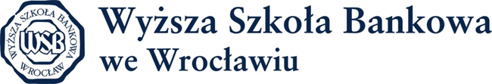

1st International Teaching Staff Week
Wrocław 9-13th May

Application Form
Title
Name and Surname
Gender

Home University
(name, country, city)
Erasmus Code
Position at Home University
Department/Unit

Teaching Programme area

Contact details (e-mail, telephone )

Teaching Programme Details
Subject of the presentation
Type (lecture, workshop etc.)
Duration
Other requirements, please specify.

Please e-mail the completed form by 5th April 2016 to international@wsb.wroclaw.pl
The number of seats is limited. Please take into account that after applying you are not automatically selected.
I agree to process my personal data by the administrator – WSB University in Wrocław based in Wrocław for marketing and promotional purposes connected to its activities pursuant to the Act on Personal Data Protection dated 29th August 1997 (Journal of Laws 2002, No. 101, item 926 as amended) any time also in the future.

