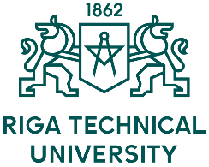 | Application Form  6th INTERNATIONAL STAFF TRAINING WEEK  May 22 – 26, 2017  Riga Technical University
Title:
Surname:
Name:
City and country:
University:
Department:
Position:
Main responsibilities:

Contact data
Address:
E-mail:
Mobile telephone number:

Please state the reasons for participation at the International Week:

Individual meetings
(Please indicate 2 choices (1, 2) in order of preference) !!!
Faculty of Architecture and Urban Planning
Faculty of Civil Engineering
Faculty of Computer Science and Information Technology
Faculty of Electronics and Telecommunications
Faculty of Engineering Economics and Management
Faculty of E-Learning Technologies and Humanities
Faculty of Materials Science and Applied Chemistry
Faculty of Power and Electrical Engineering
Faculty of Mechanical Engineering, Transport and Aeronautics
Riga Business School
Scientific Library
Other (please specify):
Social program  (100 EUR to be paid in cash during registration)  - Lunch (Monday, 22 May)  - Welcome dinner (Monday, 22 May)  - Riga city tour (Tuesday, 23 May)  - Tour to Jūrmala (including lunch) (Thursday, 25 May) | YES | NO
Please send your completed application form before 15 March 2017 to jolanta.jurevica@rtu.lv

