Erasmus Staff Training Week - University of Murcia 22-26 April 2024*

International Offices: BIP “Towards a seamless mobility”
*Online session (Mandatory for Blended Intensive Program)
Date: 16/04/2024
Time: 14:3
Monday 22 | Tuesday 23 | Wednesday 24 | Thursday 25 | Friday 26
INSTITUTIONAL WELCOME | OUR BUSINESS: | OUR BUSINESS: | CULTURAL VISIT: CARTAGENA | WEEK FINALE
La Merced Campus: “Hemiciclo” Faculty of Arts | Espinardo Campus: “Lumeras de Castro”  Anexo between Biology and Chemistry | Espinardo Campus:  “Lumeras de Castro”  Anexo between Biology and Chemistry | Cartagena visit  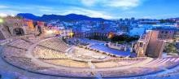 | La Merced Campus: “Antonio Soler”  Faculty of Arts
9.00-9.30:  Registration, welcome coffee  9.30-10.15:  Institutional Welcome by authorities, presentation of participants and group photo  10.15-11.30:  Group 1 (KA- 131)  The role of mobility in European Universities Initiative alliances". Jorge Piernas.  Group 2 (KA 171) Administrative procedures  11.30-12.00  Coffee Break  12.00-13.30:  The language centre: a door to university culture  14.00- Lunch  18.00:  Meeting point: Tourism Office Plaza Cardenal Belluga  2-hour guided tour around Murcia. | 9.00: Meeting point Rector Soler building  “Lumeras de Castro” Room Chemistry Faculty  9.15-10.15:  Making blended mobility work in your institution  10.15-11.00:  How to implement a successful Internationalization at Home strategy  11.00-11.30:  Coffee break  11:30-12:15:  Strategies and tactics for successful marketing results  12.15-13.30: Workshop  14.00: Lunch  Free time  19.45 Meeting point “Rincón de Pepe” Hotel main door  20.00: Welcome Dinner  “Rincón de Pepe” restaurant | 8.55: Meeting point  Main door “Aulario”  9.00-10.00:  Inclusive internationalization: How to assure the participation of students with disabilities in international opportunities.  10.15-11.00: Workshop  11.00 – 11.30:  Coffee break  11.30-13.00:  Creating partnerships beyond Europe: KA171  13.30: Lunch at Campus Espinardo  Free time:  meeting Euniwell students | 8.30: Meeting point: Mercadona Plaza Circular  8.45: Bus to Cartagena  9.30-11.30: Guided tour around Cartagena. https://www.turismore giondemurcia.es/es/ca rtagena/  11.30- 12.00:  Free time  12.00-13.30:  Visit to Roman forum museum  https://puertodeculturas.cartagena.es/ficha_barrio_foro.asp?idioma=2  13.45:  Bus to Cabo de Palos Beach  14.30:  Lunch at seaside restaurant  16. 00 :  Free time at Cabo de Palos. (Visit to the lighthouse) https://www.turismore giondemurcia.es/es/ca bo_de_palos/  18.30: Bus to Murcia | 9.30 – 10.00:  The Faculty of Arts: good practices in Internationalization  10.00-10.30:  Equipping student ambassadors as agents for improving mobility experiences  Aulario La Merced (canteen)  10.30-11.30: Coffee  break  ALAS Aulario La Merced  11.30-12.00: Survey  and conclusions  12.00-12.30:  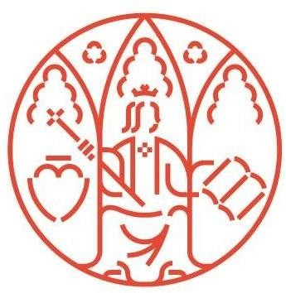  Certificates and farewell.
** All activities are intended only for participants in UMU Staff Week, lunches and dinner are free of charge

Área de Relaciones Internacionales Edificio Rector Soler
Campus Espinardo 30100 — Murcia ESPAÑA

internacionales@um.es
Tlf.: +34 868 88 40 74 um.es

