Erasmus Staff Training Week - University of Murcia 22-26 April 2024 Language Service (Intensive Spanish Course B1 level)
Monday 22 | Tuesday 23 | Wednesday 24 | Thursday 25 | Friday 26
INSTITUTIONAL WELCOME | OUR BUSINESS: Spanish language course | OUR BUSINESS: Spanish Language course | CULTURAL VISIT: CARTAGENA | WEEK FINALE
La Merced Campus: “Hemiciclo” Faculty of Arts | Espinardo Campus: Rector Soler building. | Espinardo Campus: Rector Soler building. | Cartagena visit  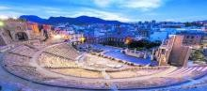 | Saavedra Fajardo building. City centre Arts Faculty- La Merced Campus
9.00-9.30:  Registration, welcome coffee  9.30-10.15:  Institutional Welcome by authorities and group photo  10.15-11.30:  Spanish Course:  Breaking the ice  11.30-12.00  Coffee Break  12.00-13.30:  Spanish Course:  People and culture  Meeting point: Tourism Office Plaza Cardenal Belluga  18.00:  2-hour guided tour around Murcia. | 9.00 – 13.00:  Spanish Course  Classroom 1 (Aula 1)  Plans and projects. The world of work in Spain and Europe.  What is it like to live in Murcia?  Expressing opinions  13:00-15.00:  Free time  15.00 – 18.00:  Spanish Course  Telling and evaluating different experiences.  Keeping a conversation in Spanish  19.45 Meeting point “Rincón de Pepe” Hotel main door  20.00: Welcome Dinner  “Rincón de Pepe” restaurant | 9.00 – 13.00:  Spanish Course  Classroom1 (Aula 1)  Audiovisual culture in modern day Spain.  Moods and emotions  13.30: Lunch at Espinardo Campus  Free time:  The city as a rich source of learning | 8.30: Meeting point: Mercadona. Plaza Circular  8.45: Bus to Cartagena  9.30-12.00: Guided tour around Cartagena. https://www.turismore giondemurcia.es/es/ca rtagena/  12.00-13.30:  Visit to Roman forum museum  https://puertodeculturas.cartagena.es/ficha_barrio_foro.asp?idioma=2  13.45:  Bus to Cabo de Palos Beach  14.30:  Lunch at seaside restaurant  16.00 :  Free time at Cabo de Palos. (Boat Trip around the coastline) https://www.turismore giondemurcia.es/es/ca bo_de_palos/  18.30: Bus to Murcia | 9.00 – 11.00:  Spanish course  (2h)  Students presentations and final discussion.  Aulario La Merced (canteen)  ALAS Aulario La Merced  11.30-12.00: Survey  and conclusions  “Antonio Soler” Room. Aulario  12.00-12.30:  Certificates and farewell.
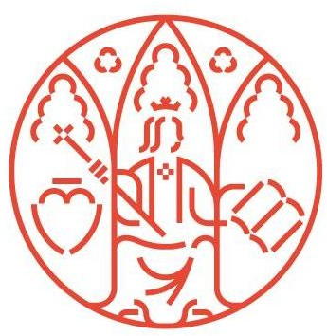
** All activities are intended only for participants in UMU Staff Week, lunches and dinner are free of charge

Área de Relaciones Internacionales
Edificio Rector Soler Campus Espinardo 30100 — Murcia ESPAÑA

internacionales@um.es
Tlf.: +34 868 88 40 74 um.es

