Monday 25th May | Tuesday 26th May | Wednesday 27th May | Thursday 28th May | Friday 29th May
Arrival of participants  11:30 Reception and Welcome  12:30  Guided  Campus Tour  13:30 Lunch on Campus | 10:00  Crash Course of Spanish Language  11:30 Coffee Break  12:00  Presentation UCAM and Internationalization  13:30 Lunch on campus | 10:00  Staff Mobility workshop  11:30 Coffee Break  12:00  UCAM University of Sports  13:00 Visit UCAM Sport Center | 10:00  Presentation Region of Murcia  11:30 Coffee Break  12:00 Research and Innovation at UCAM  13:00 Spanish Wine Tasting  14:00 Lunch on Campus | Possibility for Teaching or individual meetings with Faculty Members or International Staff  13:00 Awarding of Certificates and closing  Departure of participants
16:00  City Tour Murcia | 15:00  Visit UCAM campus  In Cartagena | 16:00  Visit UCAM Voluntary Activities | 20:30  Tapas Dinner (optional aprox. 15 €)
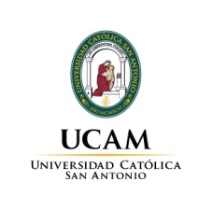
I INTERNATIONAL STAFF WEEK UCAM 25-29 MAY 2015

