Monday 29/5 | Tuesday 30/5 | Wednesday 31/5 | Thursday 1/6 | Friday 2/6
Arrival of participants  10:30 Registration and Welcome word  11:30  Guided Campus Tour  Meeting Point:  Statue of the Pope at the entrance of UCAM  12:30  Presentation Region of Murcia | 10:00  Crash Course of Spanish Language  11:30 Coffee Break  12:00  Presentation UCAM and Internationalization  13:00 Spanish Wine Tasting Workshop  Gastronomy classroom | 9:30  Staff Mobility workshop I  11:30 Coffee Break  12:00  Staff Mobility Workshop II | 10:00  Research and Innovation at UCAM  11:00 Coffee Break  11:30  UCAM University of Sports  12:30 Visit UCAM Sport Center | 10:30 Awarding of Certificates and closing  Possibility for Teaching or individual meetings with Faculty Members or International Staff  Departure of participants
13:30 Lunch on Campus | 14:00 Lunch on campus | 13:00 Lunch on Campus
18:00  City Tour Murcia | 16:00  Museum Visit Murcia | 14:00 Visit to UCAM’s campus in Cartagena  (including boat trip and visit Roman Theater) | 20:00 Tapas Dinner in Murcia City  (optional aprox. 15 €)
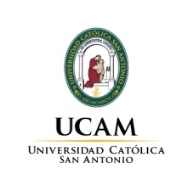
I INTERNATIONAL STAFF WEEK UCAM May 29th –June 2nd 2017
Room: Sala Capitular (ground floor Monastery Building)

