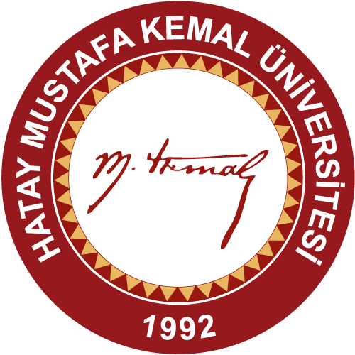

HATAY MUSTAFA KEMAL UNIVERSITY
9TH ERASMUS+ STAFF WEEK
17 - 21 Aralık 2018

HATAY MUSTAFA KEMAL UNIVERSITY
STAFF WEEK
17-21 December 2018
DRAFT PROGRAMME

16 December Sunday 2018
(Transfer of Guests from Airport to the Hotel)

17 December Monday 2018
09:30 | Transfer of Guests from Hotel to the Univ.Campus
10:00 - 10:15 | Opening Ceremony
10:15 - 10:30 | Live Music of students
10:30 - 11:00 | Presentation of Turkey
11:00 - 12:00 | Presentation of Hatay Mustafa Kemal University and Hatay
12:10 - 12:15 | Family pictures of participants
12:15 - 12:30 | Campus Tour
12:30 - 14:00 | Lunch (at the campus restaurant)
14:00 - 15:30 | Personel Teaching and Training Activities
16:00 - 18:00 | Antakya City Tour  (Ulu Mosques, Uzun Çarşı (traditional bazaar), Antakya Old houses , Habibi Neccar Mosque Ortodoks Kilisesi, Katolik Kilisesi, Sinagog churches )
19:00 | Welcome Dinner

18 December Tuesday 2018
09:30 | Transfer of Guests from Hotel to Univ.Campus
10:00 - 10:30 | Presentation of Turkish Language
10:30 - 11:30 | Presentation of Turkish Culture
11:30 - 12:00 | Erasmus Experiences of Incoming and Outgoing students
12:30 - 14:00 | Lunch (at the campus restaurant)
14:00 - 15:30 | Personel Teaching and Training Activities
16:00 - 18:00 | Antakya City Tour II  (Archelogical Museum, St.Pierre Grotto Church)
19:00 - 21:30 | Dinner:

19 December Wednesday 2018
09:30 | Transfer of Guests from Hotel to Univ.Campus
10:00 - 12:00 | Presentation of guests’ universities (about 10 minutes)
12:30 - 14:00 | Lunch
14:00-16:00 | Personel Teaching and Training Activities
16:30 | Back to Hotel
17:00-18.45 | Free Time.
18:45 | Taking guests from hotel for dinner
19:00 - 21:00 | Dinner

20 December Thursday 2018
09:30 | Transfer of Guests from Hotel to Univ.Campus)
10:00 - 12:30 | Culturel Event-(Gusts will bring some materials to introduce their country,city,university,culture and present these to Univ.students)
12:30 - 14:00 | Lunch
14:00 - 18:30 | Samandağ  (Titus Tüneli, Kaya Mezarları, Musa Ağacı)
19:00 - 21:30 | Dinner

21 December Friday 2018
10:00 - 12:00 | Traditional Breakfast
 | Free Time

22 December Saturday 2018
Departure of Guests

