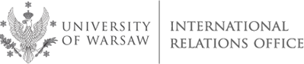

University of Warsaw (PL WARSZAW01)
International Staff Training Week
4 - 8 June, 2018

CROSS-CULTURAL COMMUNICATION. RESOLVING CONFLICTS IN A MULTI-CULTURAL COMMUNITY
Application Form

First Name

Family Name

Gender | MALE |  | FEMALE
Home University

Department

Position/Function

Phone

E-mail

Your main interests/ expectations

Would you like to visit any particular office/ department at the University of Warsaw? | YES | NO
Please specify

Would you like to meet with any staff member(s) in particular? | YES | NO
Please specify

Dietary requirements (allergy, vegetarian, etc.)

