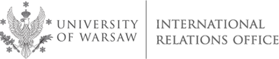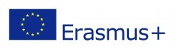

University of Warsaw (PL WARSZAW01)
International Staff Training Week
3 - 7 June, 2019

CROSS-CULTURAL COMMUNICATION. RESOLVING CONFLICTS IN A MULTI CULTURAL COMMUNITY
Application Form
First Name

Family Name

Gender | MALE |  | FEMALE
Home University

Department

Position/Function

Phone

E-mail

Your main interests/ expectations

Would you like to visit any particular office/ department at the University of Warsaw? | YES | NO
If yes, please specify

Would you like to meet with any staff member(s) in particular? | YES | NO
If yes, please specify

Dietary requirements (allergy, vegetarian, etc.)

Please send applications to:

joanna.naglowska@adm.uw.edu.pl (European countries)
joanna.wiszniewska@adm.uw.edu.pl (non-European countries)

