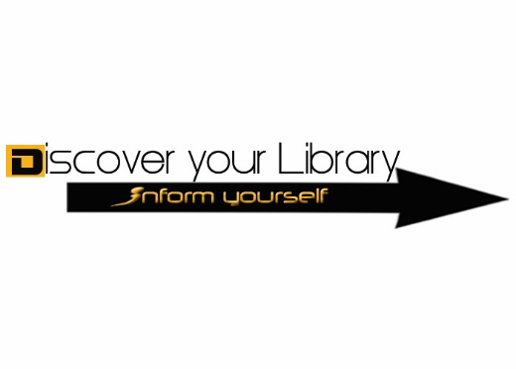
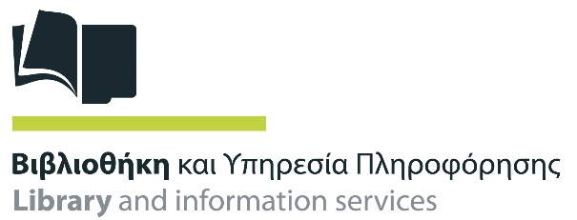

Cyprus University of Technology
Library and Information Services
Profile 2017

The Library and Information Services of the Cyprus University of Technology (CUT) was founded in 2007.

Mission/Objectives

- Serving and supporting the members of the academic community in their scientific, research, and teaching work.

- Collection development in quality, size and depth, providing access to reliable information resources throughout the University research community.

- Accumulating, preserving and making accessible of the University's research activity (academic publications and students theses and dissertations)

- Library contribution to the research, teaching and lifelong learning through information literacy courses aimed at training users to develop the necessary research skills and critical thought.

- Beneficial partnership and collaboration with other scientific institutions and libraries of Cyprus for the recording, preserving and documentation of works of popular culture, and other scientific, artistic and cultural production.

- Social contribution to the local community through the sustainability, digitization and promotion of cultural heritage.

CUT Library is a member of the following cooperation and professional organizations:
International Federation of Library Associations and Institutions (IFLA)
Ligue des Bibliothèques Europèennes de Recherche (LIBER)
European Innovative Users Group (EIUG)
Scholarly Publishing and Academic Resources Coalition (SPARC)
Confederation of Open Access Repositories (COAR)
CALIS (Cyprus Association of Librarians and Information Scientists)
CYS (Cyprus Organization for Standardization)

Since 2013, the CUT Library also holds the Presidency of the Cyprus Academic Libraries Consortium (CALC).

Library Holdings

The CUT Library collection contains about 26.200 items, including books, journals, audio-visual material, leaflets, pamphlets, etc. The Library also offers access to approximately 23.500 e-journal titles, 180 bibliographical and full-text databases and 452.120 e-books.

In 2015, the Library had more than 6,700 members and about 82,000 virtual visits.

Library hours

 | September – May | June – August
Monday – Friday | 8:30 a.m. – 10:00 p.m. | 8:30 a.m. – 2:30 p.m.
Saturday | 10:00 a.m. – 4:00 p.m. | Closed

Library hours are subject to change during holiday and examination periods.

Library Services
Borrowing: Library materials can be borrowed by
- All members of the Cyprus University of Technology
- Members of other universities according to the cooperation agreement
- Registered inhabitants of Cyprus
Library materials can be easily checked-out or checked-in with the self-check machines in the entrance of the Library. Loan dates can be renewed before the due date in case the materials have no queue. Renewals can be made through the library online catalogue, at the Circulation Desk, by phone or by e-mail.
Printing, photocopying and scanning in the CUT Library can be made using the Library card in the Photocopying room on the ground floor during all library hours.

Electronic devices: The Library owns tablets and laptops that may be borrowed at Circulation Desk for specific loan periods. The Library members may also request to borrow tablets, digital cameras, video cameras, audiovisual equipment, books, films, and other electronics from the “CUTing Edge” Innovation Centre.

Seminars and workshops: the Library offers a range of educational seminars and workshops (in groups or in person) to meet the interests and needs of all University researchers and students. Bookings are essential.

Electronic orders: the Library has integrated YBP Library Services' GOBI³ (Global Online Bibliographic Information) into acquisitions and selection workflows. The tool is an online interface which is used to automate and facilitate the ordering process of print material by the academic staff and to monitor the status of orders or create activity and expenditure reports.

CUT Open Access Author Fund: started in October 2013 and covers payments for eligible OA journals that have submission fees. The Fund was created to encourage and support the University staff who wishes to make their scholarly work available via open access publishing and who are required to pay article processing fees in order to make this possible.

Ask your Librarian: an innovative service in Cyprus academic libraries. 6 Subject Librarians (one for each Faculty) work with academic departments for the collection development, help users with finding information (or advice on locating), accessing or searching library's electronic resources, choosing databases, answer enquiries, organizing seminars and training sessions.

The swapping bookshelf project: The Swapping Bookshelf initiative was launched in September 2015 at the University square in Limassol and it was the first one in Cyprus. It is designed by 2 Greek architects as an alternative approach to the traditional concept of public libraries. Their vision was to design a public type of furniture based on traditional bookshelf standards that becomes a vital element of public space by disseminating knowledge and inspiring social interaction. Designed to be sustainable and low-maintenance, the bookshelf features a solar panel roof that supplies power to LED lights placed in every shelf, illuminating the books at night.

The Bookshelf is accessible 24 hours a day, seven days a week and requires no subscription or membership fees. Visitors can borrow books and check them in after a period of time. The bookshelf's collection is updated on a daily basis, since its function is based on any written material offered by the public. The swapping bookshelf promotes and adds an aesthetic, cultural and educative value to the residents and visitors. (http://vivliothiki.org/home.php)

Digital Library and electronic services

Reference and enquiry service: users can ask questions and leave comments, complaints or feedback through a chat room, electronic question form, email, etc.

Online account: all users can examine their patron record (to see the books they have borrowed, their due dates, reservations they have made, and whether they have fines to pay) by using the link “My Account” on the opening page of the electronic catalogue “Pantognostis”.

InterLibrary Loan: the Library cooperates with other Libraries in Cyprus and overseas to provide access to material not held within its collection.

Library Subject Guides: created by librarians in order to support teaching and research at the University. These Guides concentrate and organize Library resources and services by topic in order to help the students find information and access materials relevant to their department/ studies. http://libguides.cut.ac.cy/

ETDs Guide: a cooperative work between the Library and the academic departments which defines the context which the students can use to create their thesis or dissertation. The guide aims to provide guidelines by placing generally accepted scientific standards for the preparation of theses and dissertations (structure, accuracy, clarity, as well as the originality and documentation of the content). http://libguides.cut.ac.cy/etds

Library 2.0 initiatives: to support students online: blogging, social networks, RSS feeds, Catalog version for mobile devices, tagging and star rating to any item in the Library catalogue.
Blog: http://athena.cut.ac.cy/actadiurna
Facebook: Cyprus University of Technology Library / Βιβλιοθήκη Τεχνολογικού Πανεπιστημίου Κύπρου
Twitter @LibraryCUT
Google+: Cyprus University of Technology Library

RFID technology: the Library is a pioneer amongst Greek and Cypriot Libraries in adopting and implementing the Radio Frequency Identification (RFID) technology, offering upgraded borrowing services to its members and providing them with the possibility of automatic borrowing and return of material. In addition, the RFID technology assists the Library to increase its efficiency by providing an inventory of materials and their exact location on the shelves.

Research tools: The Library has subscriptions to various tools that support research, create references and bibliography, prevent plagiarism and protect copyrights, such as Refworks, Mendeley and Ephorus.

“Acta Diurna” Newsletter: The Library publishes a yearly newsletter, with news and articles about the collections, new subscriptions, library projects, and library events.

Digitization activities

The CUT Library has significant experience with digitization activities such as cultural content selection, resource description, image processing, preservation and digital library infrastructure.

One of the major priorities of the Library was to design and develop the first Institutional Repository in Cyprus, named ‘Ktisis’ (http://ktisis.cut.ac.cy/). Ktisis is an open access digital repository containing all digital content related to the various activities of the CUT as well as cultural heritage material. It demonstrates the history, the intellectual life and the research activities of the University, preserving, spreading and promoting the scientific research to the local and international community. Until today you will find in KTISIS: 1500 academic publications and 795 Electronic Theses & Dissertations (ETDs). The collection procedure of all the research activity of the university community is still in progress.

The CUT Government Board signed in 2011 the Berlin Declaration on Open Access to Scientific Knowledge. All the publications submitted to KTISIS constitute the intellectual property of the respective author and are freely available online under the terms of the “Deposit-Disposal” license and the Creative Commons license.

The online portal "Apsida" (https://apsida.cut.ac.cy/) is a digital repository which provides open access to more than 9500 digitized documents, such as photographs, stamps, books, videos, caricatures and case studies. “Apsida” is a Cyprus University of Technology project that implements innovative information technologies for developing digital cultural heritage libraries. The mission is to collect, disseminate and preserve cultural heritage material and to contribute to the cultural evolution in Cyprus. The repository is powered by Omeka open source software and the interface has been designed in order to have a responsive web design compatible with all electronic devices.

Additionally, the CUT Library participates in LoCloud (http://www.locloud.eu/), a best practice network co-funded by the European Commission under the CIP ICT-PSP programme. LoCloud is supporting institutions in making their content and metadata available to Europeana, by exploring the potential of cloud computing technologies. “Apsida” contains both the digital collections that belong to the Library and the collections of the European program “LoCloud” (in collaboration with the Digital Heritage Lab of the University). “Apsida” is the result of the collaboration between CUT and several organizations providing content of high cultural heritage importance. These collaborative partnerships and shared expertise assisted the Library to establish experience and know-how in developing cultural heritage digital libraries.

In cooperation with Pattichion Municipal Museum, Historic Archive and Research Centre of Limassol, the CUT Library records and digitizes archives and collections in order to preserve the cultural heritage of Limassol. The digitized documents are online available to researchers through the portal “Helates” (http://helates.cut.ac.cy/), but as physical objects remain the property of their respective owners. “Helates” includes the following archive collections:
- Panagiotis & Fedra Mandalios archive
- Nikolaos I. Xioutas archive
- Yiannakis Agapiou archive
- Nikos S. Nikolaides archive

Contact details
Central Library “Vassilis Michaelides”
1 Nikolaou Xiouta, 3036 Limassol, Cyprus
PO Box 50329, 3603 Limassol, Cyprus

Tel: +357 25002518
Fax: +357 25002761
E-mail: library@cut.ac.cy
Website: http://library.cut.ac.cy/

