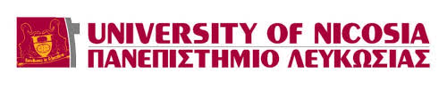

1st ERASMUS+ INTERNATIONAL STAFF WEEK
Nicosia, 7-11 March 2016

Invitation
The University of Nicosia has the pleasure to invite you to its 1st Erasmus+ International Staff Training Week, which will take place from the 7th until the 11th of March 2016.
The International Staff Week will give participants the unique opportunity to find out more about the University of Nicosia, network and share best practices with other colleagues working for the international or study abroad offices. The following topics will be covered: study mobility marketing and recruitment, application procedure and regulations, course compatibility process, transfer of academic credits, mandatory study mobility Vs optional study mobility, student traineeships, internationalization strategies, success stories and best practices.
The 5-day programme includes round table discussions, presentations, problem solving cases and social events. The main objectives of the programme include peer-learning, networking, transfer of knowledge and sharing of experiences and best practices among colleagues from partner and non-partner institutions. Participants are expected to bring into the discussion examples from their own institutions and present best practices or innovative approaches to the issues addressed.

In the context of cultural activities, the participants will have the opportunity to experience a guided tour to the divided city of Nicosia, fieldtrip to the archaeological Kourion amphitheater, a tour to Fikardou traditional village and a night out at a traditional Cypriot tavern. During the weekend, participants will have the opportunity to make the necessary arrangements and attend the annual Carnival Festival held in Limassol.
The maximum number of participants will be 30. The selection of participants will take into consideration the relevance of their professional responsibilities with the issues under discussion. If all applicants fulfill the criteria, the rule of first-come and first-served will be applied. Priority will be given to partner Universities, currently participating in the project of international credit mobility.
The staff week is open to European and international HEI’s. The participation fee is 250 euros and it should be payed via bank transfer before arrival. Participants can apply at their home institution for an Erasmus+ Staff Training Week Grant in order to cover eligible costs related to this mobility. The registration fee includes coffee-breaks, lunches and social activities mentioned in the programme (dinner at Cypriot traditional tavern, fieldtrip in divided Nicosia, fieldtrip in Fikardou traditional village and visit to the archaeological site of Kourion amphitheater in Limassol).
Participants from non-EU partner Universities, currently participating in the project of international credit mobility are exempted from the registration fees and will be provided a grant to cover their eligible travelling and living expenses during the International Staff Week.
Regarding accommodation, support is provided through a selection of hotels near the University of Nicosia but participants are responsible to make their own reservations.
Please register by filling in the attached form. The deadline for receiving applications is Thursday 18th of February, 2016.
For any questions of clarifications you may need please contact the Erasmus Office team:
Dr. Evi Eftychiou, Erasmus Institutional Coordinator, eftychiou.e@unic.ac.cy, tel.0035722841727
Ms. Georgia Argyrou, Erasmus Officer, argyrou.g@unic.ac.cy, tel. 0035722841571
Ms. Stella Stylianou, Erasmus Officer, stylianou.st@unic.ac.cy, tel. 0035722841726

We are looking forward to welcoming you at the University of Nicosia and in Cyprus.
Warm regards,
Erasmus Office, University of Nicosia

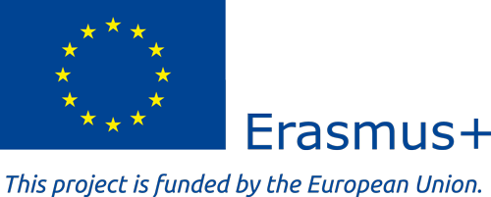

Institution website: www.unic.ac.cy
Country: Cyprus
Working Language: English
Dates: Mon, 7th March 2016 - Fri, 11th March 2016
Registration fee: 250 euro (International Credit Mobility partners exempted)
Accommodation: Recommendations provided.
Maximum no. of participants: 30
Deadline for applying: 18 February 2016
Contact: Dr. Evi Eftychiou, Erasmus Institutional Coordinator
Eftychiou.e@unic.ac.cy
tel. +35722841727

