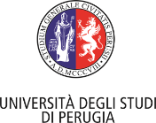
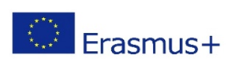
International Staff Week
PLANNING AND MANAGING
ERASMUS+ PROJECTS
December 15-18, 2019
Università degli Studi di Perugia
SURNAME
FIRST NAME
TITLE (Mr., Mrs., Dr., Prof.)
GENDER
COUNTRY
EMAIL ADDRESS
TELEPHONE (Please, indicate a phone number to which we can contact you also in Italy)
HOME UNIVERSITY
WEBSITE (Home University)
ERASMUS CODE (Home University)
POSITION/DEPARTMENT
SPECIAL REQUIREMENTS
(e.g. disabilities, food allergies, dietary restrictions)
I am interested in the activities included in the social programme  (Please, thick the relevant boxes) | - Welcome Cocktail (Sun 15th)  - Guided tour of Perugia city centre (Mon 16th)  - Lunch in Perugia city centre (Mon 16th)  - Guided Tour of Assisi (Mon 16th)  - Guided Tour: Chocolate Factory (Tues 17th)
DATES | ARRIVAL:  DEPARTURE:
BOOKED HOTEL
EXPERIENCE
(Please mention relevant experience and background in the field of Planning and Management of EU projects)
MOTIVATION
(Please explain your main interest and motivation for a staff mobility at the University of Perugia)

