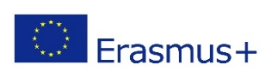
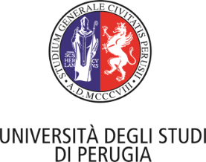
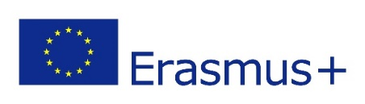
International Staff Week, 15-19 October 2018
“Internationalization and Management
of European Educational Projects”

REGISTRATION FORM
SURNAME
FIRST NAME
TITLE (Mr., Mrs., Dr., Prof.)
GENDER
COUNTRY
EMAIL ADDRESS
TELEPHONE
HOME UNIVERSITY
WEBSITE (home University)
ERASMUS CODE (home University)
POSITION/DEPARTMENT
SPECIAL REQUIREMENTS
(e.g. disabilities, food allergies, dietary restrictions)
I am interested in the activities included in the social programme  (Please, thick the relevant boxes) | - Welcome dinner (Sun, 14th)  - Guided Tour: ″Perugina‶ Chocolate Factory (Wed, 17th)  - Guided tour of Perugia city centre (Thur, 18th)  - Guided Tour of Assisi (Fri, 19th)  - Lunch in Assisi (Fri, 19th)
DATES | ARRIVAL:  DEPARTURE:
EXPERIENCE
(Please mention relevant experience and background in the field of Internationalization and EU projects)
Motivation
(Please explain your main interest and motivation for a staff mobility at the University of Perugia)

DEADLINE FOR APPLICATION: 24 September 2018 - SEND TO: area.relint@unipg.it
CONTACT: Dr. Sonia Trinari +39 075 585 2106
IMPORTANT NOTE: please specify “UNIPG staff week” in the object of the email

