  - 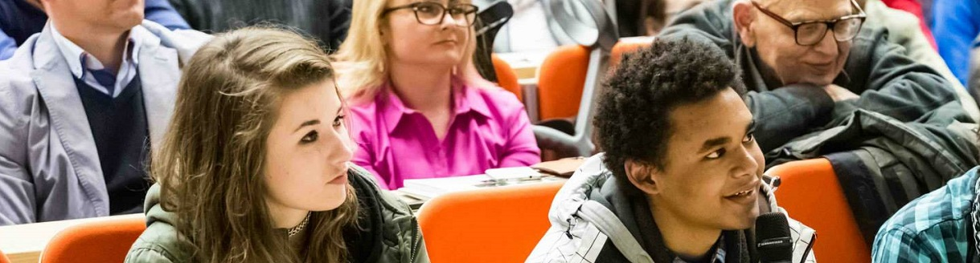

  - 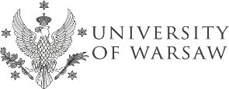 STAFF TRAINING WEEK 15-19 June 2015
(preliminary program)
MONDAY, 15.06.
morning ARRIVAL
12:30 Meeting at the IRO UW. Welcome address. Presentations of the participants.
13:00 Networking Lunch.
14:00 Presentation of the mission, structure, research & teaching activities of the University of Warsaw.
14:30 Presentation of the IRO UW. Internationalisation at UW.
15:00 Main Campus, Library and Garden Tour.
18:00 Pierogi workshop and dinner.

TUESDAY, 16.06.
9:30 Presentation of the participants’ home institutions.
11:00 Coffee break.
11:30 Tasks and obstacles in international cooperation: workshop.
13:00 Lunch (covered by participants).
14:00 Summary: presentation of the results of the workshop.
15:00 Student engagement in mobility support – presentation by ESN UW

WEDNesday, 17.06.
9:30 Use of new technologies in international cooperation.: mobility website, study support system USOS.
11:00 Coffee break.
11:30 ERASMUS without papers - mission “possible”?
13:00 Lunch (covered by participants).
14:00 Ochota Campus Tour.

Thursday, 18.06.
9:30 Evaluation of student and staff mobility: on-line evaluation questionnaires, language tests. Presentation and discussion.
11:00 Coffee break.
11:30 Webinars and other interactive tools in internationalization
13:00 Lunch (covered by participants).
14:00 Social Media in mobility – brainstorming and best practices session.
15:30 Wrap-up. Farewell coffee. (Erasmus STT documents)

friday, 19.06.
9:00 Individual visits at University of Warsaw’ faculties (by prior appointment)
OR Day Trip to Warsaw outskirts (for interested participants)
DEPARTURE

